**Sample Configurations**

**EVPN VXLAN IRB Sample Configuration**

In the following topology, we are connecting a Layer 2 site with a Layer 3 site using Layer 3 EVPN (type-5 route). The right side leaves are MLAG leaves and have SVI 10 in VRF-Blue. A number of directly connected hosts are simulated behind the right side leaf. The left side leaves are individual leaves that connect with a remote switch in **vrf** VRF-Blue to learn Layer 3 routes using BGP. The left side leaves are configured as two independent Layer 3 only VTEPs.

Figure 1. Layer 3 EVPN Configuration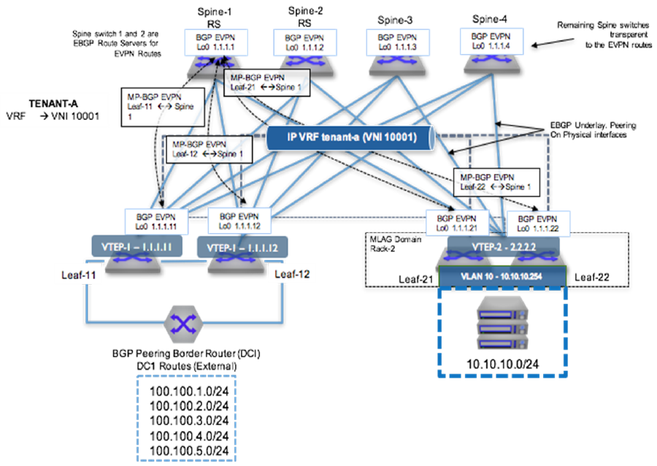

To provide VXLAN routing and bridging between the two MLAG domains, each leaf switch is EVPN peering with the four spine switches via a loopback interface.

**eBGP Underlay Configuration: Leaf-11**

Underlay configuration is straightforward and all neighbors are eBGP. Since all leaves share the same AS number, the **allowas-in** command was added in the leaf.

**interface Ethernet1**

**description Spine-1-et1/1**

**mtu 9214**

**no switchport**

**ip address 172.168.1.1/31**

**interface Ethernet8/1**

**description ck428-et8/1**

**speed forced 40gfull**

**no switchport**

**ip address 172.168.1.10/31**

**interface Loopback0**

**ip address 1.1.1.11/32**

**ip prefix-list loopback**

**seq 10 permit 1.1.1.0/24 ge 24**

**!**

**route-map loopback permit 10**

**match ip address prefix-list loopback**

**router bgp 65004**

**neighbor SPINE peer-group**

**neighbor SPINE remote-as 65001**

**neighbor SPINE allowas-in 1**

**neighbor SPINE soft-reconfiguration inbound all**

**neighbor SPINE send-community**

**neighbor 172.168.1.0 peer-group SPINE**

**neighbor 172.168.1.11 remote-as 65003**

**redistribute connected route-map loopback**

**eBGP Underlay Configuration: Spine-1**

**interface Ethernet1/1**

**description Leaf-11-et1**

**mtu 9214**

**no switchport**

**ip address 172.168.1.0/31**

**interface Loopback0**

**ip address 1.1.1.1/32**

**!**

**ip prefix-list loopback**

**seq 10 permit 1.1.1.0/24 ge 24**

**!**

**route-map loopback permit 10**

**match ip address prefix-list loopback**

**!**

**router bgp 65001**

**neighbor 172.168.1.1 remote-as 65004**

**redistribute connected route-map loopback**

**VRF Configuration: Leaf-11**

VRF-Blue is configured on all the left leaves. The left leaves have pure Layer 3 interfaces and the right side has ***SVI 10***.

**vrf instance VRF-Blue**

**ip routing vrf VRF-Blue**

**interface Ethernet36**

**no switchport**

**vrf VRF-Blue**

**ip address 172.168.1.9/31**

**router bgp 65004**

**vrf VRF-Blue**

**neighbor 172.168.1.8 remote-as 65005**

**VRF Configuration: Leaf-21**

**vlan 10**

**vrf instance VRF-Blue**

**ip routing vrf VRF-Blue**

**interface Vlan10**

**vrf VRF-Blue**

**ip address virtual 10.10.10.1/24**

**ip virtual-router mac-address 00:aa:aa:aa:aa:aa**

**interface Port-Channel3**

**switchport mode trunk**

**mlag 3**

**VXLAN Configuration: Leaf-11**

Make sure all VTEPs have unique loopback0 addresses to represent unique VTEP identifiers. For every VNI that EVPN receives, a dynamic VLAN is allocated, so it is a good practice to keep the same VNI.

**interface VXLAN1**

**VXLAN source-interface Loopback0**

**VXLAN udp-port 4789**

**VXLAN vrf VRF-Blue vni 10001**

**VXLAN Configuration: Leaf-21**

**interface VXLAN1**

**VXLAN source-interface Loopback0**

**VXLAN udp-port 4789**

**VXLAN vrf VRF-Blue vni 10001**

**EVPN Configuration: Leaf-11**

Leaf establishes the EVPN neighborship with all four spines for redundancy. EVPN neighborship is on the loopback address and the **multihop** keyword is used. Make sure to disable the IPv4 address family for EVPN neighbors.

Since the spine is acting like a route-reflector for EVPN routes, make sure to configure the next-hop-unchanged.

**router bgp 65004**

**neighbor SPINE_EVPN peer-group**

**neighbor SPINE_EVPN remote-as 65001**

**neighbor SPINE_EVPN update-source Loopback0**

**neighbor SPINE_EVPN ebgp-multihop 3**

**neighbor SPINE_EVPN send-community extended**

**neighbor SPINE_EVPN maximum-routes 12000**

**neighbor 1.1.1.1 peer-group SPINE_EVPN**

**!**

**address-family evpn**

**neighbor SPINE_EVPN activate**

**!**

**address-family ipv4**

**no neighbor SPINE_EVPN activate**

**EVPN Configuration: Leaf-21**

**router bgp 65002**

**neighbor SPINE_EVPN peer-group**

**neighbor SPINE_EVPN remote-as 65001**

**neighbor SPINE_EVPN update-source Loopback0**

**neighbor SPINE_EVPN allowas-in 1**

**neighbor SPINE_EVPN ebgp-multihop 3**

**neighbor SPINE_EVPN send-community extended**

**neighbor SPINE_EVPN maximum-routes 12000**

**neighbor 1.1.1.1 peer-group SPINE_EVPN**

**!**

**address-family evpn**

**neighbor SPINE_EVPN activate**

**!**

**address-family ipv4**

**no neighbor SPINE_EVPN activate**

**EVPN Configuration: Spine-1**

**router bgp 65004**

**neighbor SPINE_EVPN peer-group**

**neighbor SPINE_EVPN remote-as 65001**

**neighbor SPINE_EVPN update-source Loopback0**

**neighbor SPINE_EVPN ebgp-multihop 3**

**neighbor SPINE_EVPN send-community extended**

**neighbor SPINE_EVPN maximum-routes 12000**

**neighbor 1.1.1.1 peer-group SPINE_EVPN**

**!**

**address-family evpn**

**neighbor SPINE_EVPN activate**

**!**

**address-family ipv4**

**no neighbor SPINE_EVPN activate**

**Advertise VRF Routes in EVPN: Leaf-11**

By configuring VRF under **router-bgp**, you are advertising routes from that VRF into EVPN using the RD/RT. The remote end can install the route by importing the RT.

***Leaf-11*** has routes in ***VRF-Blue*** learned through eBGP with the neighbor down south. Since the routes are already in BGP VRF table, we do not want to configure the **redistribute** command.

**router bgp 65004**

**neighbor SPINE_EVPN peer-group**

**neighbor SPINE_EVPN remote-as 65001**

**neighbor SPINE_EVPN update-source Loopback0**

**neighbor SPINE_EVPN ebgp-multihop 3**

**neighbor SPINE_EVPN send-community extended**

**neighbor SPINE_EVPN maximum-routes 12000**

**neighbor 1.1.1.1 peer-group SPINE_EVPN**

**!**

**address-family evpn**

**neighbor SPINE_EVPN activate**

**!**

**address-family ipv4**

**no neighbor SPINE_EVPN activate**

**Advertise VRF Routes in EVPN: Leaf-21**

On the other hand ***Leaf-21*** wants to export the connected SVI into EVPN and therefore require **redistribute connected** command.

**router bgp 65002**

**neighbor SPINE_EVPN peer-group**

**neighbor SPINE_EVPN remote-as 65001**

**neighbor SPINE_EVPN update-source Loopback0**

**neighbor SPINE_EVPN allowas-in 1**

**neighbor SPINE_EVPN ebgp-multihop 3**

**neighbor SPINE_EVPN send-community extended**

**neighbor SPINE_EVPN maximum-routes 12000**

**neighbor 1.1.1.1 peer-group SPINE_EVPN**

**!**

**address-family evpn**

**neighbor SPINE_EVPN activate**

**!**

**address-family ipv4**

**no neighbor SPINE_EVPN activate**

**Multi-Tenant EVPN VXLAN IRB Sample Configuration**

The following configuration example shows a deployment using both symmetric and asymmetric IRB, with VLAN-based and VLAN-aware bundle services; and eBGP overlay and underlay.

Figure 2. Tenant-A: Symmetric IRB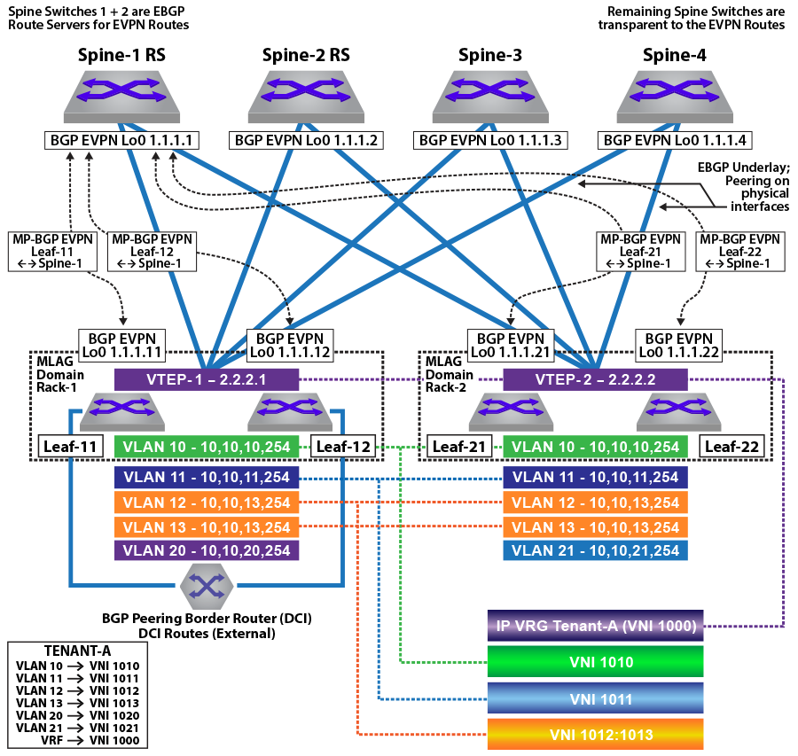Figure 3. Tenant-B: Asymmetric IRB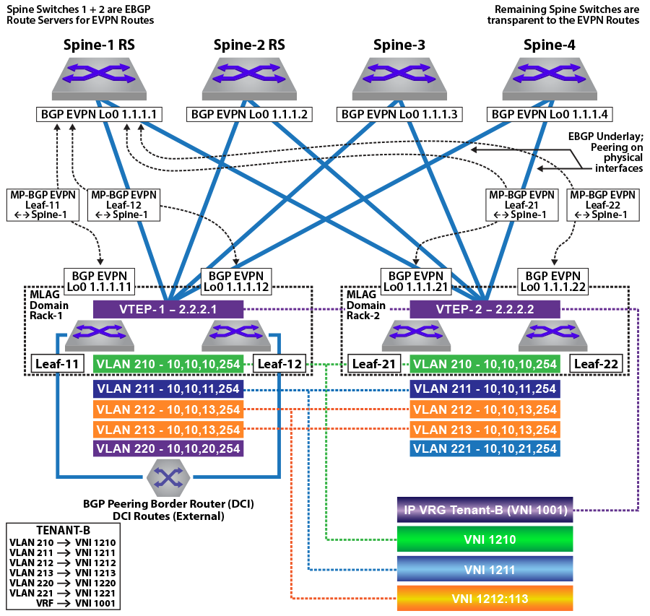

In the symmetric and asymmetric IRB configurations illustrated in the figures above, for ***Tenant-A***, four subnets are stretched across the two MLAG domains with two subnets (***VLAN 10***, ***10.10.10.0/24*** and ***VLAN 11***, ***10.10.11.0/24***) configured as a VLAN-based service and two other subnets (***VLAN 12***,***10.10.12.0/24*** and ***VLAN 13***, ***10.10.13.0/24***) as a VLAN-aware bundle service.

For ***Tenant-B***, four subnets are stretched across the two MLAG domains with two subnets (***VLAN 210***, ***10.10.10.0/24*** and ***VLAN 211***,***10.10.11.0/24***) configured as a VLAN-based service, and two other subnets (***VLAN 212***,***10.10.12.0/24*** and ***VLAN 213***,***10.10.13.0/24***) as a VLAN-aware bundle service.

In addition, each MLAG domain has a single local subnet (***Rack-1*** subnet ***10.10.20.0/24*** and ***Rack-2*** subnet ***10.10.21.0/24***) for the tenant. To provide direct distributed routing, each leaf switch is configured with the same virtual IP address for the four stretched subnets. The virtual IP address is configured in both physical leaf switches of the relevant MLAG domain for the local-only subnets.

For each MLAG domain, a logical VTEP is created with the same shared loopback address. For ***Rack-1***, the logical VTEP IP is ***2.2.2.1*** and for the ***Rack-2***, the logical VTEP IP is ***2.2.2.2***. Directly connected to each leaf switch is a host, which is a member of one of the two IP subnets. To provide Layer 2 connectivity across the racks, VXLAN bridging is enabled by mapping VLAN to VNIs as detailed in the diagram.

To provide IP connectivity across all subnets, both stretched and directly connected, an IP-VRF is shared between the two MLAG domains for the tenant. This is used as a transit network to announce and forward the locally attached subnets. Each leaf switch is EVPN peering with the four spine switches via a loopback interface on the leaf and again on the spine switches. To provide external connectivity, ***Leaf-11*** and ***Leaf-12*** are eBGP peering via the tenants’ VRFs with the border routers. Both core routers are advertising external prefixes for Internet and any remote site connectivity (default route and IP prefixes from the other DC for the tenant). To provide connectivity within the EVPN domain, the leaf switches (***Leaf-21*** and ***Leaf-22***) re-advertise the prefixes into the tenant’s VRF via a type-5 route advertisement, with a next-hop equal to the advertising VTEP.

**MLAG Configuration: Leaf-11 and Leaf-12**

**Leaf-11 MLAG Configuration**

**spanning-tree mode mstp**

**no spanning-tree vlan-id 4093-4094**

**!**

**ip virtual-router mac-address mlag-peer**

**!**

**vlan 4094**

**name MLAG_PEER**

**trunk group MLAG**

**!**

**vlan 4093**

**name LEAF_PEER_L3**

**trunk group LEAF_PEER_L3**

**!**

**interface Vlan4094**

**ip address 172.168.10.1/30**

**!**

**interface Port-Channel100**

**description port-channel to access switch**

**switchport trunk allowed vlan 10-13,20,210-213,220**

**switchport mode trunk**

**mlag 1**

**!**

**interface Port-Channel1000**

**switchport mode trunk**

**switchport trunk group LEAF_PEER_L3**

**switchport trunk group MLAG**

**!**

**mlag configuration**

**domain-id Rack-1**

**local-interface Vlan4094**

**peer-address 172.168.10.2**

**peer-link Port-Channel1000**

**Leaf-12 MLAG Configuration**

**spanning-tree mode mstp**

**no spanning-tree vlan-id 4093-4094**

**!**

**ip virtual-router mac-address mlag-peer**

**!**

**vlan 4094**

**name MLAG_PEER**

**trunk group MLAG**

**!**

**vlan 4093**

**name LEAF_PEER_L3**

**trunk group LEAF_PEER_L3**

**!**

**interface Vlan4094**

**ip address 172.168.10.2/30**

**!**

**interface Port-Channel100**

**description port-channel to access switch**

**switchport trunk allowed vlan 10-13,20,210-213,220**

**switchport mode trunk**

**mlag 1**

**!**

**interface Port-Channel1000**

**switchport mode trunk**

**switchport trunk group LEAF_PEER_L3**

**switchport trunk group MLAG**

**!**

**mlag configuration**

**domain-id Rack-1**

**local-interface Vlan4094**

**peer-address 172.168.10.1**

**peer-link Port-Channel1000**

**MLAG Configuration: Leaf-21 and Leaf-22**

**Leaf-21 MLAG Configuration**

**spanning-tree mode mstp**

**no spanning-tree vlan-id 4093-4094**

**!**

**ip virtual-router mac-address mlag-peer**

**!**

**vlan 4094**

**name MLAG_PEER**

**trunk group MLAG**

**!**

**vlan 4093**

**name LEAF_PEER_L3**

**trunk group LEAF_PEER_L3**

**!**

**interface Vlan4094**

**ip address 172.168.10.1/30**

**!**

**interface Port-Channel100**

**description port-channel to access switch**

**switchport trunk allowed vlan 10-13,21,210-213,220-221**

**switchport mode trunk**

**mlag 1**

**!**

**interface Port-Channel1000**

**switchport mode trunk**

**switchport trunk group LEAF_PEER_L3**

**switchport trunk group MLAG**

**!**

**mlag configuration**

**domain-id Rack-1**

**local-interface Vlan4094**

**peer-address 172.168.10.2**

**peer-link Port-Channel1000**

**Leaf-22 MLAG Configuration**

**spanning-tree mode mstp**

**no spanning-tree vlan-id 4093-4094**

**!**

**ip virtual-router mac-address mlag-peer**

**!**

**vlan 4094**

**name MLAG_PEER**

**trunk group MLAG**

**!**

**vlan 4093**

**name LEAF_PEER_L3**

**trunk group LEAF_PEER_L3**

**!**

**interface Vlan4094**

**ip address 172.168.10.2/30**

**!**

**interface Port-Channel100**

**description port-channel to access switch**

**switchport trunk allowed vlan 10-13,21,210-213,220-221**

**switchport mode trunk**

**mlag 1**

**!**

**interface Port-Channel1000**

**switchport mode trunk**

**switchport trunk group LEAF_PEER_L3**

**switchport trunk group MLAG**

**!**

**mlag configuration**

**domain-id Rack-1**

**local-interface Vlan4094**

**peer-address 172.168.10.1**

**peer-link Port-Channel1000hannel1000**

**VLAN and Distributed IP Address Configuration: Leaf-11 and Leaf-21**

VLAN and interface configuration for ***VLAN 10*** (virtual IP address ***10.10.10.254***) and ***VLAN 11*** (virtual IP address ***10.10.11.254***), along with SVIs ***12***, ***13***, and ***20***, are similarly configured. To provide multi-tenancy, the two tenant VLANs are placed in a dedicated VRF, named ***Tenant-A***. A further five tenant VLANs are configured and assigned to VRF ***Tenant-B***.

The other VLANs are for peering, MLAG, and a unique VLAN SVI. These VLANs do not use virtual IP addresses.

The tenants’ stretched subnets (***Tenant-A***: VLANs ***10***,***11***,***12***, and ***13***; ***Tenant-B***: VLANs ***210***, ***211***, ***211***, ***212***, and ***213***) are mapped to unique overlay VXLAN VNIs. The tenants’ IP-VRF (***Tenant-A*** and ***Tenant-B***) is associated with a VNI using the **VXLAN vrf** command under the VXLAN interface. In the forwarding model for symmetric IRB, this VNI will be used as the transit VNI for routing to subnets not locally configured on the VTEP.

As a standard MLAG configuration, both leaf switches in each MLAG domain share the same logical VTEP IP address. Thus MLAG domain, ***Rack-1*** (***Leaf-11*** + ***Leaf-12***) has a shared logical VTEP IP of ***2.2.2.1*** and ***Rack-2*** (***Leaf-21*** + ***Leaf-22***) has a shared logical VTEP IP of ***2.2.2.2***.

**Leaf-11 VLAN and Distributed IP Address Configuration**

**!**

**ip virtual-router mac-address 00:aa:aa:aa:aa:aa**

**!**

**vlan 10-11,20,210-211,220,111,2111**

**!**

**vlan 12-13**

**name VLAN-AWARE-BUNDLE-TENANT-A**

**!**

**vlan 212-213**

**name VLAN-AWARE-BUNDLE-TENANT-B**

**!**

**vrf instance tenant-a**

**!**

**vrf instance tenant-b**

**!**

**interface lan10**

**mtu 9164**

**vrf tenant-a**

**ip address virtual 10.10.10.254/24**

**!**

**interface Vlan11**

**mtu 9164**

**vrf tenant-a**

**ip address virtual 10.10.11.254/24**

**!**

**interface Vlan12**

**mtu 9164**

**vrf tenant-a**

**ip address virtual 10.10.12.254/24**

**!**

**interface Vlan13**

**mtu 9164**

**vrf tenant-a**

**ip address virtual 10.10.13.254/24**

**!**

**interface Vlan20**

**mtu 9164**

**vrf tenant-a**

**ip address virtual 10.10.20.254/24**

**!**

**interface Vlan210**

**mtu 9164**

**vrf tenant-b**

**ip address virtual 10.10.10.254/24**

**!**

**interface Vlan211**

**mtu 9164**

**vrf tenant-b**

**ip address virtual 10.10.11.254/24**

**!**

**interface Vlan212**

**mtu 9164**

**vrf tenant-b**

**ip address virtual 10.10.12.254/24**

**!**

**interface Vlan213**

**mtu 9164**

**vrf tenant-b**

**ip address virtual 10.10.13.254/24**

**!**

**interface Vlan220**

**mtu 9164**

**vrf tenant-b**

**ip address virtual 10.10.20.254/24**

**!**

**interface Vlan1111**

**description Unique-highest-IP-in-each-IP-Vrf**

**mtu 9164**

**vrf tenant-a**

**ip address 223.255.255.249/30**

**!**

**interface Vlan2111**

**description Unique-highest-IP-in-each-IP-Vrf**

**mtu 9164**

**vrf tenant-b**

**ip address 223.255.255.249/30**

**!**

**interface Vlan4093**

**ip address 172.168.11.1/30**

**Leaf-21 VLAN and Distributed IP Address Configuration**

**!**

**ip virtual-router mac-address 00:aa:aa:aa:aa:aa**

**!**

**vlan 10-11,20,210-211,220,111,2111**

**!**

**vlan 12-13**

**name VLAN-AWARE-BUNDLE-TENANT-A**

**!**

**vlan 212-213**

**name VLAN-AWARE-BUNDLE-TENANT-B**

**!**

**vrf instance tenant-a**

**!**

**vrf instance tenant-b**

**!**

**interface Vlan10**

**mtu 9164**

**vrf tenant-a**

**ip address virtual 10.10.10.254/24**

**!**

**interface Vlan11**

**mtu 9164**

**vrf tenant-a**

**ip address virtual 10.10.11.254/24**

**!**

**interface Vlan12**

**mtu 9164**

**vrf tenant-a**

**ip address virtual 10.10.12.254/24**

**!**

**interface Vlan13**

**mtu 9164**

**vrf tenant-a**

**ip address virtual 10.10.13.254/24**

**!**

**interface Vlan21**

**mtu 9164**

**vrf tenant-a**

**ip address virtual 10.10.21.254/24**

**!**

**interface Vlan210**

**mtu 9164**

**vrf tenant-b**

**ip address virtual 10.10.10.254/24**

**!**

**interface Vlan211**

**mtu 9164**

**vrf tenant-b**

**ip address virtual 10.10.11.254/24**

**!**

**interface Vlan212**

**mtu 9164**

**vrf tenant-b**

**ip address virtual 10.10.12.254/24**

**!**

**interface Vlan213**

**mtu 9164**

**vrf tenant-b**

**ip address virtual 10.10.13.254/24**

**!**

**interface Vlan221**

**mtu 9164**

**vrf tenant-b**

**ip address virtual 10.10.21.254/24**

**!**

**interface Vlan1111**

**description Unique-highest-IP-in-each-IP-Vrf**

**mtu 9164**

**vrf tenant-a**

**ip address 223.255.255.253/30**

**!**

**interface Vlan2111**

**description Unique-highest-IP-in-each-IP-Vrf**

**mtu 9164**

**vrf tenant-b**

**ip address 223.255.255.253/30**

**!**

**interface Vlan4093**

**ip address 172.168.11.1/30**

**!**

**VXLAN Interface Configuration: Leaf-11 and Leaf-21**

The tenants’ VLANs are mapped to unique overlay VXLAN VNIs. ***VLAN 10*** is mapped to ***VNI 1010*** on both MLAG domains, and ***VLAN 11*** is mapped to ***VNI 1011***. As standard MLAG configuration, both leaf switches in each MLAG domain share the same logical VTEP IP address. Thus MLAG domain ***Rack-1*** (***Leaf-11*** + ***Leaf-12***) has a shared logical VTEP IP of ***2.2.2.1*** and ***Rack-2*** (***Leaf-21*** + ***Leaf-22***) has a shared logical VTEP IP of ***2.2.2.2***. Also configured is the VRF-to-VXLAN mapping for ***Tenant-A***.

**Leaf-11 VXLAN Interface Configuration**

**!**

**interface Loopback1**

**ip address 2.2.2.1/32**

**!**

**interface VXLAN1**

**VXLAN source-interface Loopback1**

**VXLAN udp-port 4789**

**VXLAN vlan 10 vni 1010**

**VXLAN vlan 11 vni 1011**

**VXLAN vlan 12 vni 1012**

**VXLAN vlan 13 vni 1013**

**VXLAN vlan 20 vni 1020**

**VXLAN vlan 210 vni 1210**

**VXLAN vlan 211 vni 1211**

**VXLAN vlan 212 vni 1212**

**VXLAN vlan 213 vni 1213**

**VXLAN vlan 220 vni 1220**

**VXLAN vrf tenant-a vni 1000**

**VXLAN vrf tenant-b vni 1001**

**Leaf-21 VXLAN Interface Configuration**

**!**

**interface Loopback1**

**ip address 2.2.2.2/32**

**!**

**interface VXLAN1**

**VXLAN source-interface Loopback1**

**VXLAN udp-port 4789**

**VXLAN vlan 10 vni 1010**

**VXLAN vlan 11 vni 1011**

**VXLAN vlan 12 vni 1012**

**VXLAN vlan 13 vni 1013**

**VXLAN vlan 21 vni 1021**

**VXLAN vlan 210 vni 1210**

**VXLAN vlan 211 vni 1211**

**VXLAN vlan 212 vni 1212**

**VXLAN vlan 213 vni 1213**

**VXLAN vlan 221 vni 1221**

**VXLAN vrf tenant-a vni 1000**

**VXLAN vrf tenant-b vni 1001**

**Note:** This configuration uses VXLAN routing. For single-chip T2 and TH platforms, recirculation must be enabled. For R-Series platforms, the following configuration commands must be added:

**hardware tcam**

**system profile VXLAN-routing**

Refer to diagrams for VLAN and SVI assignment to tenant; ***Leaf-11*** also has peering out to the border router in addition to the connected SVIs.

**eBGP Underlay Configuration on the Leaf Switches**

The leaf switches for the underlay network peer with each spine on the physical interface. For EVPN route advertisement, the BGP EVPN session is between loopback addresses.

In this case, the underlay is all eBGP, and peering is on the physical interfaces. The MLAG leaves also peer with each other in the underlay to retain BGP EVPN connectivity (loopback reachability) in the unlikely case that all spine links are down. This is a failover configuration that can be implemented if there is ever the chance a leaf could be “core isolated.” The configuration can be viewed on each leaf using the command **show running-configuration section bgp**.

The following examples show the underlay configuration on all four leaf switches, and also on two of the spine switches as an example of the underlay configuration on the spine.

The configuration uses the following peer groups:

**SPINE**     configuration inherited for underlay (eBGP) peering to the spines

**SPINE_EVPN**     overlay eBGP peering between spine and leaf, using loopbacks

Figure 4. Physical Underlay Topology

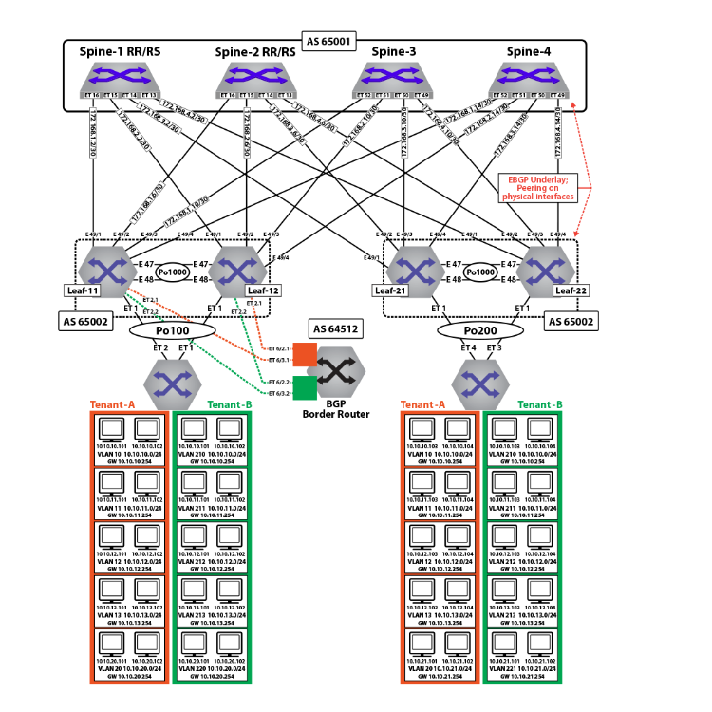

**eBGP Underlay Configuration: Leaf-11**

**route-map loopback permit 10**

**match ip address prefix-list loopback**

**!**

**route-map dont_advertise_loopbacks deny 10**

**match ip address prefix-list loopback**

**!**

**route-map dont_advertise_loopbacks permit 20**

**!**

**ip prefix-list loopback**

**seq 10 permit 1.1.1.11/32**

**seq 20 permit 1.1.1.12/32**

**seq 30 permit 1.1.1.22/32**

**seq 40 permit 1.1.1.21/32**

**seq 50 permit 2.2.2.1/32**

**seq 60 permit 2.2.2.2/32**

**!**

**router bgp 65002**

**router-id 1.1.1.11**

**maximum-paths 8 ecmp 16**

**neighbor SPINE peer-group**

**neighbor SPINE remote-as 65001**

**neighbor SPINE allowas-in 1**

**neighbor SPINE soft-reconfiguration inbound all**

**neighbor SPINE route-map loopback out**

**neighbor SPINE send-community**

**neighbor 172.168.1.1 peer-group SPINE**

**neighbor 172.168.1.5 peer-group SPINE**

**neighbor 172.168.1.9 peer-group SPINE**

**neighbor 172.168.1.13 peer-group SPINE**

**neighbor 172.168.11.2 remote-as 65004**

**neighbor 172.168.11.2 local-as 65002 no-prepend replace-as**

**neighbor 172.168.11.2 allowas-in 1**

**neighbor 172.168.11.2 maximum-routes 12000**

**redistribute connected route-map loopback**

**eBGP Underlay Configuration: Leaf-12**

**route-map loopback permit 10**

**match ip address prefix-list loopback**

**!**

**route-map dont_advertise_loopbacks deny 10**

**match ip address prefix-list loopback**

**!**

**route-map dont_advertise_loopbacks permit 20**

**!**

**ip prefix-list loopback**

**seq 10 permit 1.1.1.11/32**

**seq 20 permit 1.1.1.12/32**

**seq 30 permit 1.1.1.22/32**

**seq 40 permit 1.1.1.21/32**

**seq 50 permit 2.2.2.1/32**

**seq 60 permit 2.2.2.2/32**

**!**

**router bgp 65002**

**router-id 1.1.1.12**

**maximum-paths 8 ecmp 16**

**neighbor SPINE peer-group**

**neighbor SPINE remote-as 65001**

**neighbor SPINE allowas-in 1**

**neighbor SPINE soft-reconfiguration inbound all**

**neighbor SPINE route-map loopback out**

**neighbor SPINE send-community**

**neighbor 172.168.2.1 peer-group SPINE**

**neighbor 172.168.2.5 peer-group SPINE**

**neighbor 172.168.2.9 peer-group SPINE**

**neighbor 172.168.2.13 peer-group SPINE**

**neighbor 172.168.11.1 remote-as 65002**

**neighbor 172.168.11.1 local-as 65004 no-prepend replace-as**

**neighbor 172.168.11.1 allowas-in 1**

**neighbor 172.168.11.1 maximum-routes 12000**

**redistribute connected route-map loopback**

**eBGP Underlay Configuration: Leaf-21**

**route-map loopback permit 10**

**match ip address prefix-list loopback**

**!**

**ip prefix-list loopback**

**seq 10 permit 1.1.1.11/32**

**seq 20 permit 1.1.1.12/32**

**seq 30 permit 1.1.1.22/32**

**seq 40 permit 1.1.1.21/32**

**seq 50 permit 2.2.2.1/32**

**seq 60 permit 2.2.2.2/32**

**!**

**router bgp 65002**

**router-id 1.1.1.21**

**maximum-paths 8 ecmp 16**

**neighbor SPINE peer-group**

**neighbor SPINE remote-as 65001**

**neighbor SPINE allowas-in 1**

**neighbor SPINE soft-reconfiguration inbound all**

**neighbor SPINE route-map loopback out**

**neighbor SPINE send-community**

**neighbor SPINE maximum-routes 20000**

**neighbor 172.168.3.1 peer-group SPINE**

**neighbor 172.168.3.5 peer-group SPINE**

**neighbor 172.168.3.9 peer-group SPINE**

**neighbor 172.168.3.13 peer-group SPINE**

**neighbor 172.168.11.2 remote-as 65004**

**neighbor 172.168.11.2 local-as 65002 no-prepend replace-as**

**neighbor 172.168.11.2 allowas-in 1**

**neighbor 172.168.11.2 maximum-routes 12000**

**redistribute connected route-map loopback**

**eBGP Underlay Configuration: Leaf-22**

**route-map loopback permit 10**

**match ip address prefix-list loopback**

**!**

**ip prefix-list loopback**

**seq 10 permit 1.1.1.11/32**

**seq 20 permit 1.1.1.12/32**

**seq 30 permit 1.1.1.22/32**

**seq 40 permit 1.1.1.21/32**

**seq 50 permit 2.2.2.1/32**

**seq 60 permit 2.2.2.2/32**

**!**

**router bgp 65002**

**router-id 1.1.1.22**

**maximum-paths 8 ecmp 16**

**neighbor SPINE peer-group**

**neighbor SPINE remote-as 65001**

**neighbor SPINE allowas-in 1**

**neighbor SPINE soft-reconfiguration inbound all**

**neighbor SPINE route-map loopback out**

**neighbor SPINE send-community**

**neighbor SPINE maximum-routes 20000**

**neighbor 172.168.4.1 peer-group SPINE**

**neighbor 172.168.4.5 peer-group SPINE**

**neighbor 172.168.4.9 peer-group SPINE**

**neighbor 172.168.4.13 peer-group SPINE**

**neighbor 172.168.11.1 remote-as 65002**

**neighbor 172.168.11.1 local-as 65004 no-prepend replace-as**

**neighbor 172.168.11.2 allowas-in 1**

**neighbor 172.168.11.1 maximum-routes 12000**

**redistribute connected route-map loopback**

**EVPN BGP Configuration on the Spine Switches**

The EVPN BGP configuration on two of the spine switches is summarized below. Note that only the EVPN BGP sessions are listed for the two spine switches: the BGP underlay configuration is not included.

**EVPN BGP Configuration: Spine-1**

**route-map loopback permit 10**

**match ip address prefix-list loopback**

**!**

**ip prefix-list loopback**

**seq 10 permit 1.1.1.11/32**

**seq 20 permit 1.1.1.12/32**

**seq 30 permit 1.1.1.22/32**

**seq 40 permit 1.1.1.21/32**

**seq 50 permit 2.2.2.1/32**

**seq 60 permit 2.2.2.2/32**

**!**

**router bgp 65001**

**router-id 1.1.1.1**

**distance bgp 20 200 200**

**maximum-paths 8 ecmp 16**

**neighbor LEAF peer-group**

**neighbor LEAF remote-as 65002**

**neighbor LEAF maximum-routes 20000**

**neighbor 172.168.1.2 peer-group LEAF**

**neighbor 172.168.2.2 peer-group LEAF**

**neighbor 172.168.3.2 peer-group LEAF**

**neighbor 172.168.4.2 peer-group LEAF**

**redistribute connected route-map loopback**

**EVPN BGP Configuration: Spine-2**

**route-map loopback permit 10**

**match ip address prefix-list loopback**

**!**

**ip prefix-list loopback**

**seq 10 permit 1.1.1.11/32**

**seq 20 permit 1.1.1.12/32**

**seq 30 permit 1.1.1.22/32**

**seq 40 permit 1.1.1.21/32**

**seq 50 permit 2.2.2.1/32**

**seq 60 permit 2.2.2.2/32**

**!**

**router bgp 65001**

**router-id 1.1.1.2**

**distance bgp 20 200 200**

**maximum-paths 8 ecmp 16**

**neighbor LEAF peer-group**

**neighbor LEAF remote-as 65002**

**neighbor LEAF maximum-routes 20000**

**neighbor 172.168.1.6 peer-group LEAF**

**neighbor 172.168.2.6 peer-group LEAF**

**neighbor 172.168.3.6 peer-group LEAF**

**neighbor 172.168.4.6 peer-group LEAF**

**redistribute connected route-map loopback**

**eBGP Overlay on Leaf Switches**

The MAC VRFs and IP VRF for the tenants’ subnets are created in the BGP router context with unique Route-Distinguishers (RD) and Route-Targets (RT) attached to each MAC-VRF and IP-VRF. The RDs provide support for overlapping MAC and IP addresses across tenants, while the RTs allow control of the routes imported and exported between MAC VRFs.

To ensure all routes are correctly imported between VTEPs sharing the same Layer-2 domain, the import and export RTs are equal across the two MLAG domains. The **redistribute learned** statement under each MAC VRF ensures any locally learned MACs in the VLAN are automatically announced as type-2 routes.

The IP VRF (***Tenant-A***) is created on all leaf switches which have subnets attached to the tenant’s VRF with the same route target ensuring that routes are correctly imported and exported between VTEPs in the VRF. On ***Leaf-21*** and ***Leaf-22***, to import the external routes an eBGP session with the BGP peering router is created under the IP VRF (***Tenant-A***) context, and a peering from each to the other is created on the overlay.

**Note:** All MAC VRFs are unique, and each has its own RT, matched by the other leaves in the DC. The “tenants” as such are defined at layer 3 by assigning SVIs to the appropriate VRF. To view this assignment, use the **show ip route vrf <tenant> connected** command. Note below that VLANs ***12***-***13*** and ***212***-***213*** (shown in bold) are configured as a bundle-aware EVPN service. Also note the peering from ***Leaf-11*** to the BGP border router in each tenant VRF.

**EVPN BGP Overlay Configuration for the Tenants’ MAC VRFs and IP VRF: Leaf-11**

**route-map loopback permit 10**

**match ip address prefix-list loopback**

**!**

**route-map dont_advertise_loopbacks deny 10**

**match ip address prefix-list loopback**

**!**

**route-map dont_advertise_loopbacks permit 20**

**!**

**ip prefix-list loopback**

**seq 10 permit 1.1.1.11/32**

**seq 20 permit 1.1.1.12/32**

**seq 30 permit 1.1.1.22/32**

**seq 40 permit 1.1.1.21/32**

**seq 50 permit 2.2.2.1/32**

**seq 60 permit 2.2.2.2/32**

**!**

**router bgp 65002**

**router-id 1.1.1.11**

**maximum-paths 4**

**neighbor SPINE_EVPN peer-group**

**neighbor SPINE_EVPN remote-as 65001**

**neighbor SPINE_EVPN update-source Loopback0**

**neighbor SPINE_EVPN allowas-in 2**

**neighbor SPINE_EVPN ebgp-multihop 5**

**neighbor SPINE_EVPN send-community extended**

**neighbor SPINE_EVPN maximum-routes 12000**

**neighbor 1.1.1.1 peer-group SPINE_EVPN**

**neighbor 1.1.1.2 peer-group SPINE_EVPN**

**redistribute connected route-map loopback**

**!**

**vlan 10**

**rd 1.1.1.11:1010**

**route-target both 1010:1010**

**redistribute learned**

**!**

**vlan 11**

**rd 1.1.1.11:1011**

**route-target both 1011:1011**

**redistribute learned**

**!**

**vlan 20**

**rd 1.1.1.11:1020**

**route-target both 1020:1020**

**redistribute learned**

**!**

**vlan 210**

**rd 1.1.1.11:1210**

**route-target both 1210:1210**

**redistribute learned**

**no redistribute host-route**

**!**

**vlan 211**

**rd 1.1.1.11:1211**

**route-target both 1211:1211**

**redistribute learned**

**no redistribute host-route**

**!**

**vlan 220**

**rd 1.1.1.11:1220**

**route-target both 1220:1220**

**redistribute learned**

**no redistribute host-route**

**!**

**vlan-aware-bundle Tenant-A-VLAN-12-13**

**rd 1.1.1.11:1213**

**route-target both 12:13**

**redistribute learned**

**vlan 12-13**

**!**

**vlan-aware-bundle Tenant-B-VLAN-212-213**

**rd 1.1.1.11:21213**

**route-target both 212:213**

**redistribute learned**

**no redistribute host-route**

**vlan 212-213**

**!**

**address-family evpn**

**neighbor SPINE_EVPN activate**

**!**

**address-family ipv4**

**no neighbor SPINE_EVPN activate**

**!**

**vrf tenant-a**

**rd 1.1.1.11:1000**

**route-target import 1000:1000**

**route-target export 1000:1000**

**neighbor 192.168.168.9 remote-as 64512**

**neighbor 192.168.168.9 local-as 65002 no-prepend replace-as**

**neighbor 192.168.168.9 maximum-routes 12000**

**neighbor 223.255.255.250 peer-group LEAF_PEER_OVERLAY**

**neighbor 223.255.255.250 remote-as 65004**

**neighbor 223.255.255.250 local-as 65002 no-prepend replace-as**

**redistribute connected route-map dont_advertise_loopbacks**

**!**

**vrf tenant-b**

**rd 1.1.1.11:1001**

**route-target import 1001:1001**

**route-target export 1001:1001**

**neighbor 192.168.168.21 remote-as 64513**

**neighbor 192.168.168.21 local-as 65002 no-prepend replace-as**

**neighbor 192.168.168.21 maximum-routes 12000**

**neighbor 223.255.255.249 peer-group LEAF_PEER_OVERLAY**

**neighbor 223.255.255.249 remote-as 65004**

**neighbor 223.255.255.249 local-as 65002 no-prepend replace-as**

**redistribute connected route-map dont_advertise_loopbacks**

**EVPN BGP Overlay Configuration for the Tenants’ MAC VRFs and IP VRF: Leaf-12**

**route-map loopback permit 10**

**match ip address prefix-list loopback**

**!**

**route-map dont_advertise_loopbacks deny 10**

**match ip address prefix-list loopback**

**!**

**route-map dont_advertise_loopbacks permit 20**

**!**

**ip prefix-list loopback**

**seq 10 permit 1.1.1.11/32**

**seq 20 permit 1.1.1.12/32**

**seq 30 permit 1.1.1.22/32**

**seq 40 permit 1.1.1.21/32**

**seq 50 permit 2.2.2.1/32**

**seq 60 permit 2.2.2.2/32**

**!**

**router bgp 65002**

**router-id 1.1.1.12**

**maximum-paths 4**

**neighbor SPINE_EVPN peer-group**

**neighbor SPINE_EVPN remote-as 65001**

**neighbor SPINE_EVPN update-source Loopback0**

**neighbor SPINE_EVPN allowas-in 2**

**neighbor SPINE_EVPN ebgp-multihop 5**

**neighbor SPINE_EVPN send-community extended**

**neighbor SPINE_EVPN maximum-routes 12000**

**neighbor 1.1.1.1 peer-group SPINE_EVPN**

**neighbor 1.1.1.2 peer-group SPINE_EVPN**

**redistribute connected route-map loopback**

**!**

**vlan 10**

**rd 1.1.1.12:1010**

**route-target both 1010:1010**

**redistribute learned**

**!**

**vlan 11**

**rd 1.1.1.12:1011**

**route-target both 1011:1011**

**redistribute learned**

**!**

**vlan 20**

**rd 1.1.1.12:1020**

**route-target both 1020:1020**

**redistribute learned**

**!**

**vlan 210**

**rd 1.1.1.12:1210**

**route-target both 1210:1210**

**redistribute learned**

**no redistribute host-route**

**!**

**vlan 211**

**rd 1.1.1.12:1211**

**route-target both 1211:1211**

**redistribute learned**

**no redistribute host-route**

**!**

**vlan 220**

**rd 1.1.1.12:1220**

**route-target both 1220:1220**

**redistribute learned**

**no redistribute host-route**

**!**

**vlan-aware-bundle Tenant-A-VLAN-12-13**

**rd 1.1.1.12:1213**

**route-target both 12:13**

**redistribute learned**

**vlan 12-13**

**!**

**vlan-aware-bundle Tenant-B-VLAN-212-213**

**rd 1.1.1.12:21213**

**route-target both 212:213**

**redistribute learned**

**no redistribute host-route**

**vlan 212-213**

**!**

**address-family evpn**

**neighbor SPINE_EVPN activate**

**!**

**address-family ipv4**

**no neighbor SPINE_EVPN activate**

**!**

**vrf tenant-a**

**rd 1.1.1.12:1000**

**route-target import 1000:1000**

**route-target export 1000:1000**

**neighbor 192.168.168.13 remote-as 64512**

**neighbor 192.168.168.13 local-as 65002 no-prepend replace-as**

**neighbor 192.168.168.13 maximum-routes 12000**

**neighbor 223.255.255.249 peer-group LEAF_PEER_OVERLAY**

**neighbor 223.255.255.249 remote-as 65002**

**neighbor 223.255.255.249 local-as 65004 no-prepend replace-as**

**redistribute connected route-map dont_advertise_loopbacks**

**!**

**vrf tenant-b**

**rd 1.1.1.12:1001**

**route-target import 1001:1001**

**route-target export 1001:1001**

**neighbor 192.168.168.23 remote-as 64513**

**neighbor 192.168.168.23 local-as 65002 no-prepend replace-as**

**neighbor 192.168.168.23 maximum-routes 12000**

**neighbor 223.255.255.249 peer-group LEAF_PEER_OVERLAY**

**neighbor 223.255.255.249 remote-as 65002**

**neighbor 223.255.255.249 local-as 65004 no-prepend replace-as**

**redistribute connected route-map dont_advertise_loopbacks**

**EVPN BGP Overlay Configuration for the Tenants’ MAC VRFs and IP VRF: Leaf-21**

**route-map loopback permit 10**

**match ip address prefix-list loopback**

**!**

**route-map dont_advertise_loopbacks deny 10**

**match ip address prefix-list loopback**

**!**

**route-map dont_advertise_loopbacks permit 20**

**!**

**router bgp 65002**

**router-id 1.1.1.21**

**maximum-paths 4**

**neighbor SPINE_EVPN peer-group**

**neighbor SPINE_EVPN remote-as 65001**

**neighbor SPINE_EVPN update-source Loopback0**

**neighbor SPINE_EVPN allowas-in 2**

**neighbor SPINE_EVPN ebgp-multihop 5**

**neighbor SPINE_EVPN send-community extended**

**neighbor SPINE_EVPN maximum-routes 12000**

**neighbor 1.1.1.1 peer-group SPINE_EVPN**

**neighbor 1.1.1.2 peer-group SPINE_EVPN**

**redistribute connected route-map loopback**

**!**

**vlan 10**

**rd 1.1.1.21:1010**

**route-target both 1010:1010**

**redistribute learned**

**!**

**vlan 11**

**rd 1.1.1.21:1011**

**route-target both 1011:1011**

**redistribute learned**

**!**

**vlan 21**

**rd 1.1.1.21:1021**

**route-target both 1021:1021**

**redistribute learned**

**!**

**vlan 210**

**rd 1.1.1.21:1210**

**route-target both 1210:1210**

**redistribute learned**

**no redistribute host-route**

**!**

**vlan 211**

**rd 1.1.1.21:1211**

**route-target both 1211:1211**

**redistribute learned**

**no redistribute host-route**

**!**

**vlan 221**

**rd 1.1.1.21:1221**

**route-target both 1221:1221**

**redistribute learned**

**no redistribute host-route**

**!**

**vlan-aware-bundle Tenant-A-VLAN-12-13**

**rd 1.1.1.21:1213**

**route-target both 12:13**

**redistribute learned**

**vlan 12-13**

**!**

**vlan-aware-bundle Tenant-B-VLAN-212-213**

**rd 1.1.1.21:21213**

**route-target both 212:213**

**redistribute learned**

**redistribute host-route**

**vlan 212-213**

**!**

**address-family evpn**

**neighbor SPINE_EVPN activate**

**!**

**address-family ipv4**

**no neighbor SPINE_EVPN activate**

**!**

**vrf tenant-a**

**rd 1.1.1.21:1000**

**route-target import 1000:1000**

**route-target export 1000:1000**

**neighbor 223.255.255.254 remote-as 65002**

**neighbor 223.255.255.254 next-hop-self**

**neighbor 223.255.255.254 update-source Vlan1111**

**neighbor 223.255.255.254 allowas-in 1**

**neighbor 223.255.255.254 maximum-routes 12000**

**redistribute connected route-map dont_advertise_loopbacks**

**!**

**vrf tenant-b**

**rd 1.1.1.21:1001**

**route-target import 1001:1001**

**route-target export 1001:1001**

**neighbor 223.255.255.254 remote-as 65002**

**neighbor 223.255.255.254 next-hop-self**

**neighbor 223.255.255.254 update-source Vlan2111**

**neighbor 223.255.255.254 allowas-in 1**

**neighbor 223.255.255.254 maximum-routes 12000**

**redistribute connected route-map dont_advertise_loopbacks**

**EVPN BGP Overlay Configuration for the Tenants’ MAC VRFs and IP VRF: Leaf-22**

**route-map loopback permit 10**

**match ip address prefix-list loopback**

**!**

**route-map dont_advertise_loopbacks deny 10**

**match ip address prefix-list loopback**

**!**

**route-map dont_advertise_loopbacks permit 20**

**!**

**router bgp 65002**

**router-id 1.1.1.22**

**maximum-paths 4**

**neighbor SPINE_EVPN peer-group**

**neighbor SPINE_EVPN remote-as 65001**

**neighbor SPINE_EVPN update-source Loopback0**

**neighbor SPINE_EVPN allowas-in 2**

**neighbor SPINE_EVPN ebgp-multihop 5**

**neighbor SPINE_EVPN send-community extended**

**neighbor SPINE_EVPN maximum-routes 12000**

**neighbor 1.1.1.1 peer-group SPINE_EVPN**

**neighbor 1.1.1.2 peer-group SPINE_EVPN**

**redistribute connected route-map loopback**

**!**

**vlan 10**

**rd 1.1.1.22:1010**

**route-target both 1010:1010**

**redistribute learned**

**!**

**vlan 11**

**rd 1.1.1.22:1011**

**route-target both 1011:1011**

**redistribute learned**

**!**

**vlan 21**

**rd 1.1.1.22:1021**

**route-target both 1021:1021**

**redistribute learned**

**!**

**vlan 210**

**rd 1.1.1.22:1210**

**route-target both 1210:1210**

**redistribute learned**

**no redistribute host-route**

**!**

**vlan 211**

**rd 1.1.1.22:1211**

**route-target both 1211:1211**

**redistribute learned**

**no redistribute host-route**

**!**

**vlan 221**

**rd 1.1.1.22:1221**

**route-target both 1221:1221**

**redistribute learned**

**no redistribute host-route**

**!**

**vlan-aware-bundle Tenant-A-VLAN-12-13**

**rd 1.1.1.22:1213**

**route-target both 12:13**

**redistribute learned**

**vlan 12-13**

**!**

**vlan-aware-bundle Tenant-B-VLAN-212-213**

**rd 1.1.1.22:21213**

**route-target both 212:213**

**redistribute learned**

**no redistribute host-route**

**vlan 212-213**

**!**

**address-family evpn**

**neighbor SPINE_EVPN activate**

**!**

**address-family ipv4**

**no neighbor SPINE_EVPN activate**

**!**

**vrf tenant-a**

**rd 1.1.1.22:1000**

**route-target import 1000:1000**

**route-target export 1000:1000**

**neighbor 223.255.255.253 remote-as 65002**

**neighbor 223.255.255.253 next-hop-self**

**neighbor 223.255.255.253 update-source Vlan1111**

**neighbor 223.255.255.253 allowas-in 1**

**neighbor 223.255.255.253 maximum-routes 12000**

**redistribute connected route-map dont_advertise_loopbacks**

**!**

**vrf tenant-b**

**rd 1.1.1.22:1001**

**route-target import 1001:1001**

**route-target export 1001:1001**

**neighbor 223.255.255.253 remote-as 65002**

**neighbor 223.255.255.253 next-hop-self**

**neighbor 223.255.255.253 update-source Vlan2111**

**neighbor 223.255.255.253 allowas-in 1**

**neighbor 223.255.255.253 maximum-routes 12000**

**redistribute connected route-map dont_advertise_loopbacks**

**eBGP Overlay on Spine Switches**

The EVPN BGP configuration on the spine switches is summarised in the following examples. Note that only the EVPN BGP sessions are listed for two spine switches; the BGP underlay configuration is not included.

**EVPN BGP Overlay Configuration: Spine-1**

**!**

**router bgp 65001**

**router-id 1.1.1.1**

**distance bgp 20 200 200**

**maximum-paths 8 ecmp 16**

**neighbor LEAF_EVPN peer-group**

**neighbor LEAF_EVPN remote-as 65002**

**neighbor LEAF_EVPN update-source Loopback0**

**neighbor LEAF_EVPN ebgp-multihop 5**

**neighbor LEAF_EVPN send-community extended**

**neighbor LEAF_EVPN next-hop-unchanged**

**neighbor LEAF_EVPN maximum-routes 12000**

**neighbor 1.1.1.11 peer-group LEAF_EVPN**

**neighbor 1.1.1.12 peer-group LEAF_EVPN**

**neighbor 1.1.1.21 peer-group LEAF_EVPN**

**neighbor 1.1.1.22 peer-group LEAF_EVPN**

**!**

**address-family evpn**

**neighbor LEAF_EVPN activate**

**!**

**address-family ipv4**

**no neighbor LEAF_EVPN activate**

**!**

**address-family ipv6**

**no neighbor LEAF_EVPN activate**

**!**

**EVPN BGP Overlay Configuration: Spine-2**

**!**

**router bgp 65001**

**router-id 1.1.1.2**

**distance bgp 20 200 200**

**maximum-paths 8 ecmp 16**

**neighbor LEAF_EVPN peer-group**

**neighbor LEAF_EVPN remote-as 65002**

**neighbor LEAF_EVPN update-source Loopback0**

**neighbor LEAF_EVPN ebgp-multihop 5**

**neighbor LEAF_EVPN send-community extended**

**neighbor LEAF_EVPN next-hop-unchanged**

**neighbor LEAF_EVPN maximum-routes 12000**

**neighbor 1.1.1.11 peer-group LEAF_EVPN**

**neighbor 1.1.1.12 peer-group LEAF_EVPN**

**neighbor 1.1.1.21 peer-group LEAF_EVPN**

**neighbor 1.1.1.21 peer-group LEAF_EVPN**

**!**

**address-family evpn**

**neighbor LEAF_EVPN activate**

**!**

**address-family ipv4**

**no neighbor LEAF_EVPN activate**

**!**

**address-family ipv6**

**no neighbor LEAF_EVPN activate**

**!**

**Symmetric IRB Configuration (Tenant-A)**

In symmetric IRB, the host routes are generated by advertising type-2 routes with both the MAC VRF VNI and the routing (or VRF) VNI. On ***Leaf-11***, the MAC VRFs for ***Tenant-A*** are left in their default configuration (i.e., redistributing host routes). The following example shows the configuration for the MAC VRF.

**MAC VRF Configuration for Tenant-A: Leaf-11**

The **redistribute learned** commands below cause type-2 routes to be advertised with two labels: in ***VLAN 10***, ***1010*** and ***1000***; in ***VLAN 11***, 1011 and ***1000***; in ***VLAN 21***, ***1021*** and ***1000***.

**vlan 10**

**rd 1.1.1.11:1010**

**route-target both 1010:1010**

**redistribute learned**

**!**

**vlan 11**

**rd 1.1.1.11:1011**

**route-target both 1011:1011**

**redistribute learned**

**!**

**vlan 21**

**rd 1.1.1.11:1021**

**route-target both 1021:1021**

**redistribute learned**

**!**

With this configuration, any locally learned MAC-IP binding on a leaf switch will be advertised as a type-2 route with two labels. For example, on switches ***Leaf-21*** and ***Leaf-22***, any MAC-IP binding locally learned on subnets ***10.10.10.0/24***, ***10.10.11.0/24***, or ***10.10.21.0/24*** will be advertised as type-2 routes with two labels (the MAC VRF of ***1010***, ***1011***, or ***1021*** and the IP VRF of ***1000***) and two route targets equal to the relevant MAC VRF for the host and IP VRF for the tenant (***1000:1000***). The remote leaf switches (***Leaf-11*** and ***Leaf-12***), will now learn the host route in the IP VRF.

In addition to advertising the type-2 routes with dual labels, the switch will still advertise type-5 routes. This ensures connectivity to the remote subnet even when no host on the subnet has been learned. With both a layer-2 route and layer-3 host route for Server-3 learned on the MAC VRF(***1010***) and the IP VRF (***1000***) on ***Leaf-11***, traffic ingressing on ***Leaf-11*** from the local subnet ***10.10.10.103*** (i.e., ***VLAN 10***) will be VXLAN bridged based on the MAC VRF entry. Traffic ingressing from outside the subnet (i.e., ***VLAN 11***, ***12***, ***13***, or ***20***) will be routed to the host via the IP VRF host route.

The VLAN-aware bundle VLAN type-2 routes are advertised with the VNI ID within the update.

The type-5 routes are advertised with the IP VRF Route Distinguisher and the VNI label, signifying that the forwarding path for the prefix would be the IP VRF. The imported routes from the eBGP peering with the BGP border router in ***Leaf-11*** and ***Leaf-12*** are imported by both switches, and redistributed via type-5 advertisements to ***Leaf-21*** and ***Leaf-22***.

**Asymmetric IRB Configuration (Tenant-B)**

In asymmetric IRB, the host routes are generated by advertising type-2 routes with just the MAC VRF VNI. On leaf 11, the MAC VRFs for ***Tenant-B*** are configured with no redistribute host route within the MAC VRF configuration. The following example shows the configuration for the MAC VRF.

**MAC VRF Configuration for Tenant-B: Leaf-11**

The **no redistribute host-route** commands below cause type-2 routes to be advertised with a single label: in ***VLAN 210***, ***1110***; in ***VLAN 211***, ***1211***; in ***VLAN 220***, ***1220***; and in the VLAN-aware bundle (***Tenant-B-VLAN-212-213***), ***1212*** and ***1213***.

**vlan 210**

**rd 1.1.1.11:1210**

**route-target both 1210:1210**

**redistribute learned**

**no redistribute host-route**

**!**

**vlan 211**

**rd 1.1.1.11:1211**

**route-target both 1211:1211**

**redistribute learned**

**no redistribute host-route**

**!**

**vlan 220**

**rd 1.1.1.11:1220**

**route-target both 1220:1220**

**redistribute learned**

**no redistribute host-route**

**!**

**vlan-aware-bundle Tenant-B-VLAN-212-213**

**rd 1.1.1.11:21213**

**route-target both 212:213**

**redistribute learned**

**no redistribute host-route**

**vlan 212-213**

**!**

With this configuration, any locally learned MAC-IP binding on a leaf switch will be advertised as a type-2 route with a single label. For example, on ***Leaf-11*** and ***Leaf-12***, any MAC-IP binding locally learned on subnets ***10.10.10.0/24***, ***10.10.11.0/24***, or ***10.10.21.0/24*** will be advertised as type-2 routes with a single label, the MAC VRF (***1210***, ***1211***, ***1220***, ***1212***, ***1213***, or ***21111***). The IP VRF (***1001***) still advertises the type-5 prefix routes. This ensures connectivity to the remote subnet even when no host on the subnet has been learned.

The VLAN-aware bundle VLAN type-2 routes are advertised with the VNI ID within the update.

**EVPN MPLS Sample Configuration**

This section describes configuring and verifying BGP VPN, which has steps similar to the EVPN VXLAN demonstration. Here, we examine BGP EVPN layer 3 VPN over LDP, Segment Routing (ISIS-SR), and BGP-SR transport LSPs. This highlights the difference between the transport and the VPN overlay service.

**Layer 3 VPN Over ISIS-SR**

The following figures illustrate the overview of combined control and data planes.

Figure 5. Control Plane Tenant-A Over ISIS-SR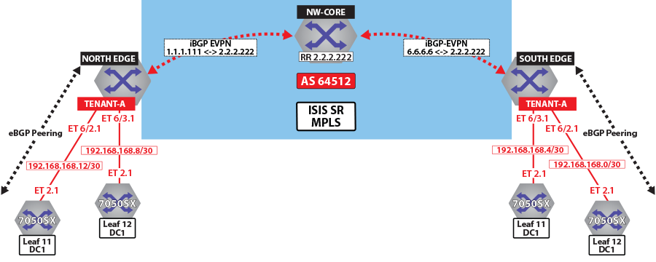Figure 6. Control Plane Tenant-B over ISIS-SR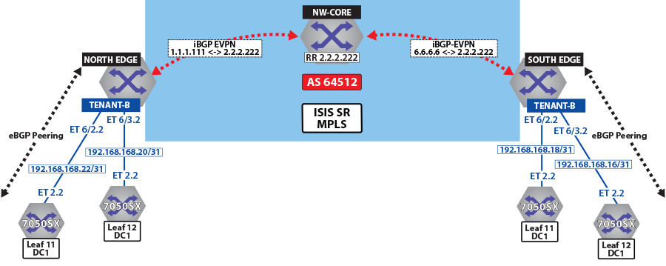Figure 7. Control Plane and Forwarding Tenant-A Over ISIS-SR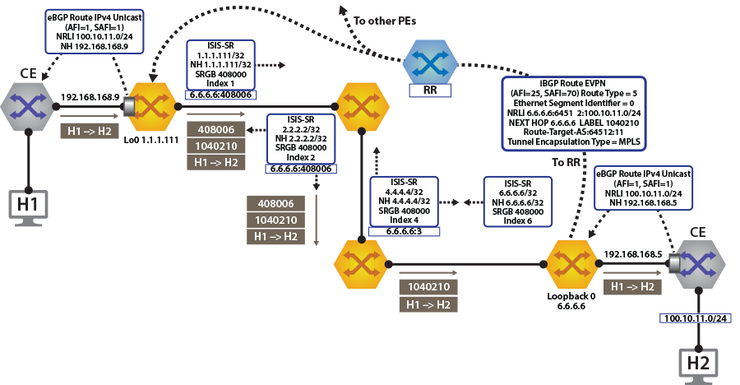

The North Edge router has an eBGP peering session out to ***Leaf-11*** and ***Leaf-12*** in ***DC1***, while the South Edge router has peerings to ***Leaf-11*** and***Leaf-12*** in ***DC2***. Tenant-a has few additional local interfaces used for testing.

**Example**

The **show ip route vrf tenant-a connected** command displays the interfaces assigned to the tenant-a of North Edge router.

**north-edge# show ip route vrf tenant-a connected**

**VRF: tenant-a**

**Codes: C - connected, S - static, K - kernel,**

**O - OSPF, IA - OSPF inter area, E1 - OSPF external type 1,**

**E2 - OSPF external type 2, N1 - OSPF NSSA external type 1,**

**N2 - OSPF NSSA external type2, B I - iBGP, B E - eBGP,**

**R - RIP, I L1 - IS-IS level 1, I L2 - IS-IS level 2,**

**O3 - OSPFv3, A B - BGP Aggregate, A O - OSPF Summary,**

**NG - Nexthop Group Static Route, V - VXLAN Control Service,**

**DH - DHCP client installed default route, M - Martian,**

**DP - Dynamic Policy Route**

**C 192.168.168.8/30 is directly connected, Ethernet6/3.1**

**C 192.168.168.12/30 is directly connected, Ethernet6/2.1**

**Activating EVPN**

In all scenarios, the EVPN must be activated under BGP and neighbors configured to exchange Layer 2 VPN/EVPN NLRI. The tenant’s VRF (tenant-a and tenant-b) is associated with a dynamically assigned label by BGP.

An activated EVPN provides the following functionalities:

* Enables the multi-agent routing protocol model, which is required for EVPN support.
* Sets the local autonomous system number to 64512 and configures IBGP neighbors that are activated for the Layer 2 VPN/EVPN address family.
* Sets the EVPN encapsulation type to MPLS.
* Specifies that Loopback0 will be used as the next-hop for all advertised EVPN routes. The underlay configuration must provide MPLS LSPs from remote PEs to this loopback interface address.

**Example**

The **service routing protocols model multi-agent** command activates EVPN on the north edge router.

**service routing protocols model multi-agent**

**router bgp 64512**

**router-id 1.1.1.111**

**maximum-paths 128 ecmp 128**

**neighbor 2.2.2.222 remote-as 64512**

**neighbor 2.2.2.222 update-source Loopback0**

**neighbor 2.2.2.222 bfd**

**neighbor 2.2.2.222 send-community extended**

**!**

**address-family evpn**

**neighbor default encapsulation mpls next-hop-self source-interface Loopback0**

**neighbor default graceful-restart**

**neighbor 2.2.2.222 activate**

**!**

**Layer 3 Overlay Configuration**

Distribution of layer 3 routes over BGP is enabled by configuring one or more IP VRFs under the router bgp configuration mode. Additionally, IP routing must be enabled in the VRF.

The VRF is assigned a unique Route-Distinguisher (RD). The RD allows the PE to advertise EVPN routes for the same IP prefix that have been exported by different VRFs. The NLRI RouteKey of a route exported from the VRF’s IPv4 table into EVPN consists of both the RD and the original IP prefix.

The Route-Target (RT) extended communities for the VRF. The RTs are associated with all routes exported from the VRF. Received EVPN type-5 routes carrying at least one RT matching the VRFs configuration are imported into the VRF. The route target directives are configured under the IPv4 or IPv6 address- family.

**Example**

The **vrf tenant-a** and **vrf tenant-a** commands define overlay VRFs (***tenant-a*** and ***tenant-b***) on the VTEP of North Edge router and enables IPv4 routing within them.

**vrf tenant-a**

**rd 1.1.1.1:64512**

**route-target import evpn 64512:11**

**route-target export evpn 64512:11**

**router-id 1.1.1.111**

**neighbor 192.168.168.10 remote-as 65002**

**neighbor 192.168.168.10 local-as 64512 no-prepend replace-as**

**neighbor 192.168.168.10 default-originate**

**neighbor 192.168.168.10 maximum-routes 12000**

**neighbor 192.168.168.14 remote-as 65002**

**neighbor 192.168.168.14 local-as 64512 no-prepend replace-as**

**neighbor 192.168.168.14 default-originate**

**neighbor 192.168.168.14 maximum-routes 12000**

**redistribute connected**

**redistribute static**

**!**

**vrf tenant-b**

**rd 1.1.1.1:64513**

**route-target import evpn 64513:11**

**route-target export evpn 64513:11**

**router-id 1.1.1.111**

**neighbor 192.168.168.20 remote-as 65002**

**neighbor 192.168.168.20 local-as 64513 no-prepend replace-as**

**neighbor 192.168.168.20 maximum-routes 12000**

**neighbor 192.168.168.22 remote-as 65002**

**neighbor 192.168.168.22 local-as 64513 no-prepend replace-as**

**neighbor 192.168.168.22 maximum-routes 12000**

**redistribute connected**

**redistribute static**

**!**

**Verifying BGP EVPN Layer 3 VPN**

Show commands are executed in the North Edge router to view routes to the South Edge router. Execute the same commands in the South Edge router to view vice-versa routes.

**Examples**

* The **show bgp evpn summary** command displays the status of EVPN peers in North Edge router.
* **north-edge# show bgp evpn summary**
* **BGP summary information for VRF default**
* **Router identifier 1.1.1.111, local AS number 64512**
* **Neighbor Status Codes: m - Under maintenance**
* **Neighbor V AS MsgRcvd MsgSent InQ OutQ Up/Down State**
* **PfxRcd PfxAcc**

**2.2.2.222 4 64512 195 127 0 0 01:13:31 Estab 78 78**

* The **show bgp evpn route-type ip-prefix ipv4 next-hop 6.6.6.6** command displays all BGP EVPN ip prefix routes received from the South Edge router (***6.6.6.6***). Not all are advertised via the ***RR 2.2.2.222***.

**Note:** Each entry in the table represents a BGP path. The path specific information includes Route-Distinguisher and IP prefix. Paths are either received from EVPN peers or exported from local VRFs.

**north-edge# show bgp evpn route-type ip-prefix ipv4 next-hop 6.6.6.6**

**BGP routing table information for VRF default**

**Router identifier 1.1.1.111, local AS number 64512**

**Route status codes: s - suppressed, * - valid, > - active, # - not installed, E - ECMP head, e - ECMP**

**S - Stale, c - Contributing to ECMP, b - backup**

**% - Pending BGP convergence**

**Origin codes: i - IGP, e - EGP, ? - incomplete**

**AS Path Attributes: Or-ID - Originator ID, C-LST - Cluster List, LL Nexthop - Link Local Nexthop**

**Network Next Hop Metric LocPref Weight Path**

**\* > RD: 6.6.6.6:64512 ip-prefix 0.0.0.0/0**

**6.6.6.6 0 100 0 ? Or-ID: 6.6.6.6 C-LST: 2.2.2.222**

**\* > RD: 6.6.6.6:64513 ip-prefix 0.0.0.0/0**

**6.6.6.6 0 100 0 ? Or-ID: 6.6.6.6 C-LST: 2.2.2.222**

**\* > RD: 6.6.6.6:64514 ip-prefix 10.255.255.0/30**

**6.6.6.6 - 100 0 65010 i Or-ID: 6.6.6.6 C-LST: 2.2.2.222**

**\* > RD: 6.6.6.6:64512 ip-prefix 100.10.10.0/24**

**6.6.6.6 - 100 0 65006 i Or-ID: 6.6.6.6 C-LST: 2.2.2.222**

**\* > RD: 6.6.6.6:64513 ip-prefix 100.10.10.0/24**

**6.6.6.6 - 100 0 65006 i Or-ID: 6.6.6.6 C-LST: 2.2.2.222**

**\* > RD: 6.6.6.6:64512 ip-prefix 100.10.10.103/32**

**6.6.6.6 - 100 0 65006 65005 65006 i Or-ID: 6.6.6.6 C-LST: 2.2.2.222**

**\* > RD: 6.6.6.6:64512 ip-prefix 100.10.10.104/32**

**6.6.6.6 - 100 0 65006 65005 65006 i Or-ID: 6.6.6.6 C-LST: 2.2.2.222**

**\* > RD: 6.6.6.6:64512 ip-prefix 100.10.11.0/24**

**6.6.6.6 - 100 0 65006 i Or-ID: 6.6.6.6 C-LST: 2.2.2.222**

**\* > RD: 6.6.6.6:64513 ip-prefix 100.10.11.0/24**

**6.6.6.6 - 100 0 65006 i Or-ID: 6.6.6.6 C-LST: 2.2.2.222**

**\* > RD: 6.6.6.6:64512 ip-prefix 100.10.11.103/32**

**6.6.6.6 - 100 0 65006 65005 65006 i Or-ID: 6.6.6.6 C-LST: 2.2.2.222**

**\* > RD: 6.6.6.6:64512 ip-prefix 100.10.11.104/32**

**6.6.6.6 - 100 0 65006 65005 65006 i Or-ID: 6.6.6.6 C-LST: 2.2.2.222**

* The **show bgp evpn route-type ip-prefix 100.10.11.0/24 detail** command displays a detailed view of the IP prefix route for ***100.10.11.0/24***. The output again includes the RD and IP prefix identifying the route. As seen above the route is received from the route reflector, and the VPN label for ***tenant-a*** is ***958810***.
* **north-edge# show bgp evpn route-type ip-prefix 100.10.11.0/24 detail**
* **BGP routing table information for VRF default**
* **Router identifier 1.1.1.111, local AS number 64512**
* **BGP routing table entry for ip-prefix 100.10.11.0/24, Route Distinguisher: 6.6.6.6:64512**
* **Paths: 1 available**
* **65006**
* **6.6.6.6 from 2.2.2.222 (2.2.2.222)**
* **Origin IGP, metric -, localpref 100, weight 0, valid, internal, best**
* **Extended Community: Route-Target-AS:64512:11 TunnelEncap:tunnelTypeMpls**
* **MPLS label: 958810**
* **BGP routing table entry for ip-prefix 100.10.11.0/24, Route Distinguisher: 6.6.6.6:64513**
* **Paths: 1 available**
* **65006**
* **6.6.6.6 from 2.2.2.222 (2.2.2.222)**
* **Origin IGP, metric -, localpref 100, weight 0, valid, internal, best**
* **Extended Community: Route-Target-AS:64513:11 TunnelEncap:tunnelTypeMpls**

**MPLS label: 953372**

**Note:** ***Tenant-a*** and ***tenant-b*** share the same route. Therefore, both route with ***RD 6.6.6.6:64513*** and ***RT 64513:11***.

* The **show ip bgp vrf tenant-a** command displays the BGP table for VRF in tenant-a containing imported EVPN routes. Each entry in the table represent a BGP path that is either locally redistributed / received into the VRF or imported from the EVPN table.
* **north-edge# show ip bgp vrf tenant-a**
* **BGP routing table information for VRF tenant-a**
* **Router identifier 1.1.1.111, local AS number 64512**
* **Route status codes: s - suppressed, * - valid, > - active, # - not installed, E - ECMP head, e - ECMP**
* **S - Stale, c - Contributing to ECMP, b - backup, L - labeled-unicast**
* **% - Pending BGP convergence**
* **Origin codes: i - IGP, e - EGP, ? - incomplete**
* **AS Path Attributes: Or-ID - Originator ID, C-LST - Cluster List, LL Nexthop - Link Local Nexthop**
* **Network Next Hop Metric LocPref Weight Path**
* **\* > 0.0.0.0/0 6.6.6.6 0 100 0 ? Or-ID: 6.6.6.6 C-LST: 2.2.2.222**
* **\* >Ec 10.10.10.0/24 192.168.168.14 - 100 0 65002 i**
* **\* ec 10.10.10.0/24 192.168.168.10 - 100 0 65002 i**
* **\* >Ec 10.10.10.103/32 192.168.168.14 - 100 0 65002 i**
* **\* ec 10.10.10.103/32 192.168.168.10 - 100 0 65002 i**
* **\* >Ec 10.10.10.104/32 192.168.168.14 - 100 0 65002 i**
* **\* >Ec 10.10.44.1/32 192.168.168.14 - 100 0 65002 i**
* **\* ec 10.10.44.1/32 192.168.168.10 - 100 0 65002 i**
* **\* > 100.10.10.0/24 6.6.6.6 - 100 0 65006 i Or-ID: 6.6.6.6 C-LST: 2.2.2.222**
* **\* > 100.10.10.103/32 6.6.6.6 - 100 0 65006 65005 65006 i Or-ID: 6.6.6.6**
* **C-LST: 2.2.2.222**
* **\* > 100.10.10.104/32 6.6.6.6 - 100 0 65006 65005 65006 i Or-ID: 6.6.6.6**
* **C-LST: 2.2.2.222**
* **C-LST: 2.2.2.222**
* **\* > 100.10.21.102/32 6.6.6.6 - 100 0 65006 65005 65006 i Or-ID: 6.6.6.6**
* **C-LST: 2.2.2.222**
* **\* > 100.10.30.0/24 6.6.6.6 - 100 0 65006 i Or-ID: 6.6.6.6 C-LST: 2.2.2.222**
* **\* > 100.10.32.0/24 6.6.6.6 - 100 0 65006 i Or-ID: 6.6.6.6 C-LST: 2.2.2.222**
* **\* > 192.168.168.0/30 6.6.6.6 - 100 0 i Or-ID: 6.6.6.6 C-LST: 2.2.2.222**
* **\* > 192.168.168.4/30 6.6.6.6 - 100 0 i Or-ID: 6.6.6.6 C-LST: 2.2.2.222**
* **\* > 192.168.168.8/30 - - - 0 i**
* **\* Ec 192.168.168.8/30 192.168.168.14 - 100 0 65002 i**
* **\* ec 192.168.168.8/30 192.168.168.10 - 100 0 65002 i**
* **\* > 192.168.168.12/30 - - - 0 i**
* **\* Ec 192.168.168.12/30 192.168.168.14 - 100 0 65002 i**
* **\* ec 192.168.168.12/30 192.168.168.10 - 100 0 65002 i**
* **\* > 223.255.254.248/30 6.6.6.6 - 100 0 65006 i Or-ID: 6.6.6.6 C-LST: 2.2.2.222**
* **\* > 223.255.254.252/30 6.6.6.6 - 100 0 65006 65005 65006 i Or-ID: 6.6.6.6**
* **C-LST: 2.2.2.222**
* **\* >Ec 223.255.255.248/30 192.168.168.14 - 100 0 65002 i**
* **\* ec 223.255.255.248/30 192.168.168.10 - 100 0 65002 i**
* **\* >Ec 223.255.255.252/30 192.168.168.14 - 100 0 65002 i**
* **\* ec 223.255.255.252/30 192.168.168.10 - 100 0 65002 i**

**Note:** EVPN routes are received from router ***2.2.2.222*** C-List (cluster list - basically identifying this route as from a route-reflector) with originating router being ***6.6.6.6***.

* The **show ip route vrf tenant-b** command displays the BGP table for VRF in ***tenant-b*** containing imported EVPN routes.
* **north-edge# show ip route vrf tenant-b**
* **VRF: tenant-b**
* **Codes: C - connected, S - static, K - kernel,**
* **O - OSPF, IA - OSPF inter area, E1 - OSPF external type 1,**
* **E2 - OSPF external type 2, N1 - OSPF NSSA external type 1,**
* **N2 - OSPF NSSA external type2, B I - iBGP, B E - eBGP,**
* **R - RIP, I L1 - IS-IS level 1, I L2 - IS-IS level 2,**
* **O3 - OSPFv3, A B - BGP Aggregate, A O - OSPF Summary,**
* **NG - Nexthop Group Static Route, V - VXLAN Control Service,**
* **DH - DHCP client installed default route, M - Martian,**
* **DP - Dynamic Policy Route**
* **Gateway of last resort:**
* **B I 0.0.0.0/0 [200/0] via 6.6.6.6/32, IS-IS SR tunnel index 6, label 953372**
* **via 192.168.58.12, Ethernet1/1, label 408006**
* **via 192.168.59.12, Ethernet2/1, label 408006**
* **B E 10.10.10.0/24 [200/0] via 192.168.168.22, Ethernet6/2.2**
* **via 192.168.168.20, Ethernet6/3.2**
* **B E 10.10.21.0/24 [200/0] via 192.168.168.22, Ethernet6/2.2**
* **via 192.168.168.20, Ethernet6/3.2**
* **B I 100.10.10.0/24 [200/0] via 6.6.6.6/32, IS-IS SR tunnel index 6, label 953372**
* **via 192.168.58.12, Ethernet1/1, label 408006**
* **via 192.168.59.12, Ethernet2/1, label 408006**
* **C 192.168.168.20/31 is directly connected, Ethernet6/3.2**
* **C 192.168.168.22/31 is directly connected, Ethernet6/2.2**
* **B I 223.255.254.248/30 [200/0] via 6.6.6.6/32, IS-IS SR tunnel index 6, label 953372**
* **via 192.168.58.12, Ethernet1/1, label 408006**
* **via 192.168.59.12, Ethernet2/1, label 408006**
* **B I 223.255.254.252/30 [200/0] via 6.6.6.6/32, IS-IS SR tunnel index 6, label 953372**
* **via 192.168.58.12, Ethernet1/1, label 408006**
* **via 192.168.59.12, Ethernet2/1, label 408006**
* **B E 223.255.255.248/30 [200/0] via 192.168.168.22, Ethernet6/2.2**
* **via 192.168.168.20, Ethernet6/3.2**
* **B E 223.255.255.252/30 [200/0] via 192.168.168.22, Ethernet6/2.2**

**via 192.168.168.20, Ethernet6/3.2**

**Note:** If we look at the routes in the VRF for tenant-b, we see that the VPN label has now changed, whilst the transport label for ***NH 6.6.6.6*** is the same. The only difference seen in ***tenant-b***, aside from the different VPN label, is that there are no host-routes in ***tenant-b*** because within each DC ***tenant-b*** is running in asymmetric mode, therefore no host routes are generated/installed in the IP VRF.

**Layer 3 EVPN Over LDP**

The following figures illustrate an overview of the combined control and data planes.

Figure 8. Control Plane Tenant-A Over LDP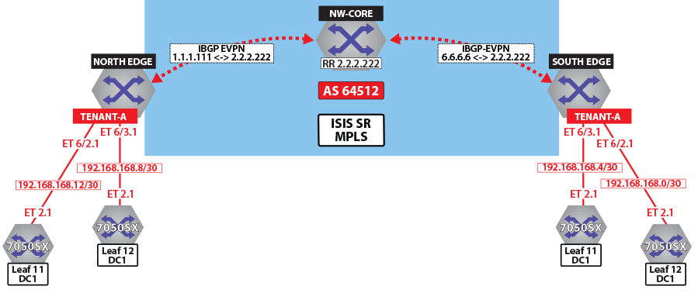Figure 9. Control Plane Tenant-B over LDP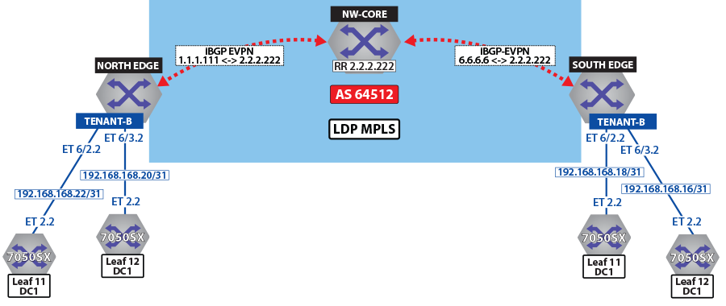Figure 10. Control Plane & Forwarding Tenant-A Over LDP

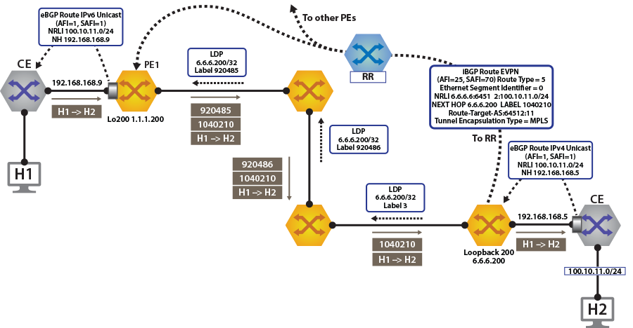

To switch to using the MPLS LDP transport, change the next-hop advertised for EVPN routes. As illustrated above, the next hop needs to be set to loopback ***200*** to use the LDP LSP.

This is achieved by configuring the next-hop for EVPN routes on both North Edge and South Edge routes. The output again includes the RD and IP prefixes identifying the route. As seen in the output, we now have the NH set to ***6.6.6.200*** for ***tenant-a*** and ***tenant-b***.

**router bgp 64512**

**!**

**address-family evpn**

**neighbor default encapsulation mpls next-hop-self source-interface Loopback200**

Once this is configured, we can check the BGP updates and the routes in the VRF.

**north-edge# show bgp evpn route-type ip-prefix 100.10.11.0/24 detail**

**BGP routing table information for VRF default**

**Router identifier 1.1.1.111, local AS number 64512**

**BGP routing table entry for ip-prefix 100.10.11.0/24, Route Distinguisher: 6.6.6.6:64512**

**Paths: 1 available**

**65006**

**6.6.6.200 from 2.2.2.222 (2.2.2.222)**

**Origin IGP, metric -, localpref 100, weight 0, valid, internal, best**

**Extended Community: Route-Target-AS:64512:11 TunnelEncap:tunnelTypeMpls**

**MPLS label: 958810**

**BGP routing table entry for ip-prefix 100.10.11.0/24, Route Distinguisher: 6.6.6.6:64513**

**Paths: 1 available**

**65006**

**6.6.6.200 from 2.2.2.222 (2.2.2.222)**

**Origin IGP, metric -, localpref 100, weight 0, valid, internal, best**

**Extended Community: Route-Target-AS:64513:11 TunnelEncap:tunnelTypeMpls**

**MPLS label: 953372**

**Note:** We have the same route in tenant-a and tenant-b in DC2. Therefore, VPN label has not changed in the two other routes with ***RD 6.6.6.6:64513*** and ***RT 64513:11***, reinforcing the fact that the BGP VPN label is orthogonal to the transport label.

Finally, look at the routes in the VRF ***tenant-a***.

**north-edge# show ip route vrf tenant-a**

**VRF: tenant-a**

**Codes: C - connected, S - static, K - kernel,**

**O - OSPF, IA - OSPF inter area, E1 - OSPF external type 1,**

**E2 - OSPF external type 2, N1 - OSPF NSSA external type 1,**

**N2 - OSPF NSSA external type2, B I - iBGP, B E - eBGP,**

**R - RIP, I L1 - IS-IS ----level 1, I L2 - IS-IS level 2,**

**O3 - OSPFv3, A B - BGP Aggregate, A O - OSPF Summary,**

**NG - Nexthop Group Static Route, V - VXLAN Control Service,**

**DH - DHCP client installed default route, M - Martian,**

**DP - Dynamic Policy Route**

**Gateway of last resort:**

**B I 0.0.0.0/0 [200/0] via 6.6.6.200/32, LDP tunnel index 1, label 958810**

**via 192.168.58.12, Ethernet1/1, label 904097**

**via 192.168.59.12, Ethernet2/1, label 904098**

**B E 10.10.10.103/32 [200/0] via 192.168.168.14, Ethernet6/2.1**

**via 192.168.168.10, Ethernet6/3.1**

**B E 10.10.10.104/32 [200/0] via 192.168.168.14, Ethernet6/2.1**

**via 192.168.168.10, Ethernet6/3.1**

**B I 100.10.10.103/32 [200/0] via 6.6.6.200/32, LDP tunnel index 1, label 958810**

**via 192.168.58.12, Ethernet1/1, label 904097**

**via 192.168.59.12, Ethernet2/1, label 904098**

**B I 192.168.168.4/30 [200/0] via 6.6.6.200/32, LDP tunnel index 1, label 958810**

**via 192.168.58.12, Ethernet1/1, label 904097**

**via 192.168.59.12, Ethernet2/1, label 904098**

**C 192.168.168.8/30 is directly connected, Ethernet6/3.1**

**C 192.168.168.12/30 is directly connected, Ethernet6/2.1**

**B I 223.255.254.248/30 [200/0] via 6.6.6.200/32, LDP tunnel index 1, label 958810**

**via 192.168.58.12, Ethernet1/1, label 904097**

**via 192.168.59.12, Ethernet2/1, label 904098**

**B I 223.255.254.252/30 [200/0] via 6.6.6.200/32, LDP tunnel index 1, label 958810**

**via 192.168.58.12, Ethernet1/1, label 904097**

**via 192.168.59.12, Ethernet2/1, label 904098**

**B E 223.255.255.248/30 [200/0] via 192.168.168.14, Ethernet6/2.1**

**via 192.168.168.10, Ethernet6/3.1**

**B E 223.255.255.252/30 [200/0] via 192.168.168.14, Ethernet6/2.1**

**via 192.168.168.10, Ethernet6/3.1**

**Note:** As can be seen from the highlighted route above the label stack, the route has the same VPN route ***958810***, but the transport labels are now ***904097*** and ***904098*** on top (this is the ECMP label path to reach ***NH 6.6.6.200***).

As a comparison, let us look at the routes for ***tenant-b***.

**north-edge# show ip route vrf tenant-b**

**VRF: tenant-b**

**Codes: C - connected, S - static, K - kernel,**

**O - OSPF, IA - OSPF inter area, E1 - OSPF external type 1,**

**E2 - OSPF external type 2, N1 - OSPF NSSA external type 1,**

**N2 - OSPF NSSA external type2, B I - iBGP, B E - eBGP,**

**R - RIP, I L1 - IS-IS level 1, I L2 - IS-IS level 2,**

**O3 - OSPFv3, A B - BGP Aggregate, A O - OSPF Summary,**

**NG - Nexthop Group Static Route, V - VXLAN Control Service,**

**DH - DHCP client installed default route, M - Martian,**

**DP - Dynamic Policy Route**

**Gateway of last resort:**

**B I 0.0.0.0/0 [200/0] via 6.6.6.200/32, LDP tunnel index 1, label 953372**

**via 192.168.58.12, Ethernet1/1, label 904097**

**via 192.168.59.12, Ethernet2/1, label 904098**

**B E 10.10.10.0/24 [200/0] via 192.168.168.22, Ethernet6/2.2**

**via 192.168.168.20, Ethernet6/3.2**

**via 192.168.168.20, Ethernet6/3.2**

**B I 100.10.10.0/24 [200/0] via 6.6.6.200/32, LDP tunnel index 1, label 953372**

**via 192.168.58.12, Ethernet1/1, label 904097**

**via 192.168.59.12, Ethernet2/1, label 904098**

**via 192.168.59.12, Ethernet2/1, label 904098**

**B I 192.168.168.18/31 [200/0] via 6.6.6.200/32, LDP tunnel index 1, label 953372**

**via 192.168.58.12, Ethernet1/1, label 904097**

**via 192.168.59.12, Ethernet2/1, label 904098**

**C 192.168.168.20/31 is directly connected, Ethernet6/3.2**

**C 192.168.168.22/31 is directly connected, Ethernet6/2.2**

**B I 223.255.254.248/30 [200/0] via 6.6.6.200/32, LDP tunnel index 1, label 953372**

**via 192.168.58.12, Ethernet1/1, label 904097**

**via 192.168.59.12, Ethernet2/1, label 904098**

**B I 223.255.254.252/30 [200/0] via 6.6.6.200/32, LDP tunnel index 1, label 953372**

**via 192.168.58.12, Ethernet1/1, label 904097**

**via 192.168.59.12, Ethernet2/1, label 904098**

**B E 223.255.255.248/30 [200/0] via 192.168.168.22, Ethernet6/2.2**

**via 192.168.168.20, Ethernet6/3.2**

**B E 223.255.255.252/30 [200/0] via 192.168.168.22, Ethernet6/2.2**

**Note:** The only difference apart from the missing host routes (no host-route inject for this tenant), is the VPN label.

**Layer 3 EVPN Over BGP-SR**

The following figures illustrate an overview of the combined control and data planes.

Figure 11. Control Plane Tenant-A Over BGP-SR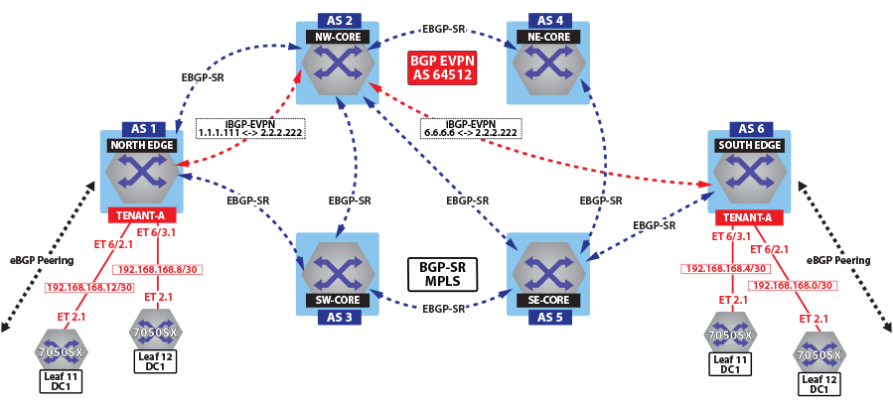Figure 12. Control Plane Tenant-B Over BGP-SR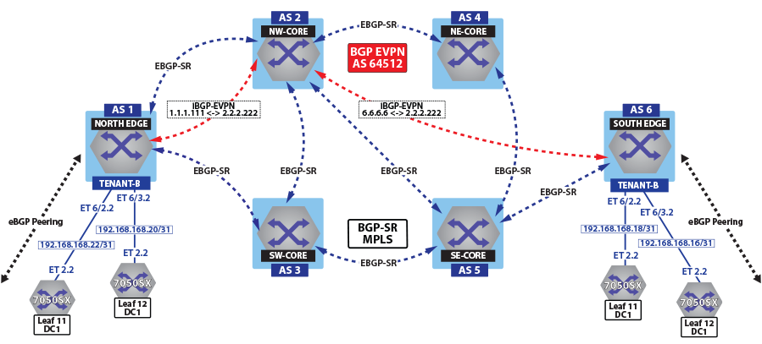Figure 13. Control Plane and Forwarding Tenant-A Over BGP-SR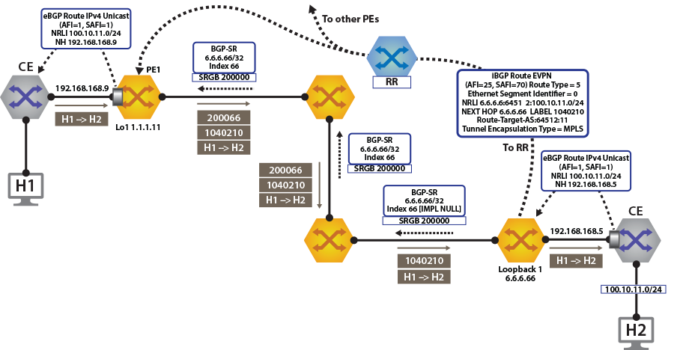

To switch to using the MPLS BGP-SR transport, we need to change the next-hop advertised for the EVPN routes. As shown in Control Plane ***tenant-b*** Over BGP-SR, the next hop needs to be set to***loopback 1*** for using the BGP-SR LSP, by configuring the next-hop for the EVPN routes.

**router bgp 64512**

**!**

**address-family evpn**

**neighbor default encapsulation mpls next-hop-self source-interface Loopback1**

Once the next-hop for the EVPN routes are configured, we can check the BGP updates and the routes in the VRF. The output again includes the RD and IP prefix identifying the route. As seen in the output, we now have the NH set to ***6.6.6.66*** for ***tenant-a*** and ***tenant-b***.

**North Edge.17:52:30# show bgp evpn route-type ip-prefix 100.10.11.0/24 detail**

**north-edge(config-if-Et2/1)#show bgp evpn route-type ip-prefix 100.10.11.0/24 detail**

**BGP routing table information for VRF default**

**Router identifier 1.1.1.111, local AS number 64512**

**BGP routing table entry for ip-prefix 100.10.11.0/24, Route Distinguisher: 6.6.6.6:64512**

**Paths: 1 available**

**65006**

**6.6.6.66 from 2.2.2.222 (2.2.2.222)**

**Origin IGP, metric -, localpref 100, weight 0, valid, internal, best**

**Extended Community: Route-Target-AS:64512:11 TunnelEncap:tunnelTypeMpls**

**MPLS label: 958810**

**BGP routing table entry for ip-prefix 100.10.11.0/24, Route Distinguisher: 6.6.6.6:64513**

**Paths: 1 available**

**65006**

**6.6.6.66 from 2.2.2.222 (2.2.2.222)**

**Origin IGP, metric -, localpref 100, weight 0, valid, internal, best**

**Extended Community: Route-Target-AS:64513:11 TunnelEncap:tunnelTypeMpls**

**MPLS label: 953372**

**Note:** Again, we have the same route in tenant-a and tenant-b in DC2. Therefore, the two other routes with ***RD 6.6.6.6:64513*** and ***RT 64513:11***. The VPN label has not changed, reinforcing the fact that the BGP VPN label is orthogonal to the transport label.

Finally, let us look at the routes in the VRF ***tenant-a***.

**North Edge.17:55:01# show ip route vrf tenant-a**

**VRF: tenant-a**

**Codes: C - connected, S - static, K - kernel,**

**O - OSPF, IA - OSPF inter area, E1 - OSPF external type 1,**

**E2 - OSPF external type 2, N1 - OSPF NSSA external type 1,**

**N2 - OSPF NSSA external type2, B I - iBGP, B E - eBGP,**

**R - RIP, I L1 - IS-IS level 1, I L2 - IS-IS level 2,**

**O3 - OSPFv3, A B - BGP Aggregate, A O - OSPF Summary,**

**NG - Nexthop Group Static Route, V - VXLAN Control Service,**

**DH - DHCP client installed default route, M - Martian,**

**DP - Dynamic Policy Route**

**Gateway of last resort:**

**B I 0.0.0.0/0 [200/0] via 6.6.6.66/32, BGP LU tunnel index 8, label 958810**

**via 192.168.58.12, Ethernet1/1, label 200066**

**via 192.168.59.12, Ethernet2/1, label 200066**

**B E 10.10.10.103/32 [200/0] via 192.168.168.14, Ethernet6/2.1**

**via 192.168.168.10, Ethernet6/3.1**

**B E 10.10.10.104/32 [200/0] via 192.168.168.14, Ethernet6/2.1**

**via 192.168.168.10, Ethernet6/3.1**

**via 192.168.168.10, Ethernet6/3.1**

**B I 100.10.10.103/32 [200/0] via 6.6.6.66/32, BGP LU tunnel index 8, label 958810**

**via 192.168.58.12, Ethernet1/1, label 200066**

**via 192.168.59.12, Ethernet2/1, label 200066**

**B I 192.168.168.4/30 [200/0] via 6.6.6.66/32, BGP LU tunnel index 8, label 958810**

**via 192.168.58.12, Ethernet1/1, label 200066**

**via 192.168.59.12, Ethernet2/1, label 200066**

**C 192.168.168.8/30 is directly connected, Ethernet6/3.1**

**C 192.168.168.12/30 is directly connected, Ethernet6/2.1**

**B I 223.255.254.248/30 [200/0] via 6.6.6.66/32, BGP LU tunnel index 8, label 958810**

**via 192.168.58.12, Ethernet1/1, label 200066**

**via 192.168.59.12, Ethernet2/1, label 200066**

**B I 223.255.254.252/30 [200/0] via 6.6.6.66/32, BGP LU tunnel index 8, label 958810**

**via 192.168.58.12, Ethernet1/1, label 200066**

**via 192.168.59.12, Ethernet2/1, label 200066**

**B E 223.255.255.248/30 [200/0] via 192.168.168.14, Ethernet6/2.1**

**via 192.168.168.10, Ethernet6/3.1**

**B E 223.255.255.252/30 [200/0] via 192.168.168.14, Ethernet6/2.1**

**via 192.168.168.10, Ethernet6/3.1**

As can be seen from the highlighted route above the label stack, the route are the transport labels ***958810*** and ***200066*** on top (this is the ECMP label path to reach ***NH 6.6.6.66***), with the ***tenant-a*** VPN label ***958810*** next in the stack, identifying the route as belonging to ***tenant-a***.

As a comparison, look at the routes for ***tenant-b***. As seen in the output, the VPN label assigned to ***tenant-b*** is ***953372***.

**north-edge# show bgp evpn route-type ip-prefix 100.10.11.0/24 detail**

**BGP routing table information for VRF default**

**Router identifier 1.1.1.111, local AS number 64512**

**BGP routing table entry for ip-prefix 100.10.11.0/24, Route Distinguisher: 6.6.6.6:64512**

**Paths: 1 available**

**65006**

**6.6.6.66 from 2.2.2.222 (2.2.2.222)**

**Origin IGP, metric -, localpref 100, weight 0, valid, internal, best**

**Extended Community: Route-Target-AS:64512:11 TunnelEncap:tunnelTypeMpls**

**MPLS label: 958810**

**BGP routing table entry for ip-prefix 100.10.11.0/24, Route Distinguisher: 6.6.6.6:64513**

**Paths: 1 available**

**65006**

**6.6.6.66 from 2.2.2.222 (2.2.2.222)**

**Origin IGP, metric -, localpref 100, weight 0, valid, internal, best**

**Extended Community: Route-Target-AS:64513:11 TunnelEncap:tunnelTypeMpls**

**MPLS label: 953372**

**north-edge#**

If we now look at the routes in the VRF for ***tenant-b***, we see that the VPN label has now changed, while the transport label (for ***NH 6.6.6.66*** is the same). The only difference seen in ***tenant-b***, aside from the different VPN label, is that there are no host-routes in ***tenant-b*** because within each DC ***tenant-b*** is running in asymmetric mode; therefore, no host routes are generated/installed in the IP VRF.

**north-edge# show ip route vrf tenant-b**

**VRF: tenant-b**

**Codes: C - connected, S - static, K - kernel,**

**O - OSPF, IA - OSPF inter area, E1 - OSPF external type 1,**

**E2 - OSPF external type 2, N1 - OSPF NSSA external type 1,**

**N2 - OSPF NSSA external type2, B I - iBGP, B E - eBGP,**

**R - RIP, I L1 - IS-IS level 1, I L2 - IS-IS level 2,**

**O3 - OSPFv3, A B - BGP Aggregate, A O - OSPF Summary,**

**NG - Nexthop Group Static Route, V - VXLAN Control Service,**

**DH - DHCP client installed default route, M - Martian,**

**DP - Dynamic Policy Route**

**Gateway of last resort:**

**B I 0.0.0.0/0 [200/0] via 6.6.6.66/32, BGP LU tunnel index 8, label 953372**

**via 192.168.58.12, Ethernet1/1, label 200066**

**via 192.168.59.12, Ethernet2/1, label 200066**

**B E 10.10.10.0/24 [200/0] via 192.168.168.22, Ethernet6/2.2**

**via 192.168.168.20, Ethernet6/3.2**

**B E 10.10.21.0/24 [200/0] via 192.168.168.22, Ethernet6/2.2**

**via 192.168.168.20, Ethernet6/3.2**

**B I 100.10.10.0/24 [200/0] via 6.6.6.66/32, BGP LU tunnel index 8, label 953372**

**via 192.168.58.12, Ethernet1/1, label 200066**

**via 192.168.59.12, Ethernet2/1, label 200066**

**B I 192.168.168.18/31 [200/0] via 6.6.6.66/32, BGP LU tunnel index 8, label 953372**

**via 192.168.58.12, Ethernet1/1, label 200066**

**via 192.168.59.12, Ethernet2/1, label 200066**

**C 192.168.168.20/31 is directly connected, Ethernet6/3.2**

**C 192.168.168.22/31 is directly connected, Ethernet6/2.2**

**B I 223.255.254.248/30 [200/0] via 6.6.6.66/32, BGP LU tunnel index 8, label 953372**

**via 192.168.58.12, Ethernet1/1, label 200066**

**via 192.168.59.12, Ethernet2/1, label 200066**

**B I 223.255.254.252/30 [200/0] via 6.6.6.66/32, BGP LU tunnel index 8, label 953372**

**via 192.168.58.12, Ethernet1/1, label 200066**

**via 192.168.59.12, Ethernet2/1, label 200066**

**B E 223.255.255.248/30 [200/0] via 192.168.168.22, Ethernet6/2.2**

**via 192.168.168.20, Ethernet6/3.2**

**B E 223.255.255.252/30 [200/0] via 192.168.168.22, Ethernet6/2.2**

**via 192.168.168.20, Ethernet6/3.2**

**EVPN VXLAN IPv6 Overlay**

The EVPN VXLAN L3 Gateway using EVPN IRB supports routing traffic from one IPv6 host to another IPv6 host on a stretched VXLAN VLAN on platforms that support ND Proxy and ND suppression. The **ipv6 address virtual** command enables the use of one MAC address for all SVI instead of one per SVI. Both EVPN IRB and VXLAN tunnel interface are required for the feature to work. The VXLAN must be configured with a VNI or the VRF for the VLAN must be configured with a VRF/VNI mapping.

**Configuring for Overlay**

The following configures the switches for global IPv6 unicast routing and IPv6 unicast routing for each VRF.

**switch(config)# ipv6 unicast-routing**

**switch(config)# ipv6 unicast-routing vrf tenant-c**

The following configures the switches with a virtual MAC address, which is used for mapping all virtual router IP addresses. For VARP configs, the address is receive-only; the switch never sends packets with this address as the source. For **ip address virtual**, the address is also used as the source for ARP packets.

**Switch(config)# ipv6 virtual-router mac-address <mac>**

The following shows the switch with IPv6 configured where one SVI uses one physical IP address.

**switch# show run int vlan 501**

**interface Vlan501**

**vrf forwarding tenant-c**

**ipv6 enable**

**ipv6 address 2004:220::1:2/112**

**ipv6 virtual-router address 2004:220::1:10**

The following shows configuration for the switch such that all SVI use the virtual MAC address and only one physical IP address.

**switch# show run int vlan 501**

**interface Vlan501**

**vrf forwarding tenant-c**

**ipv6 enable**

**ipv6 address virtual 2004:220::1:10/112**

**Limitations**

Any topology that requires a VXLAN Virtual VTEP address configuration is not supported.

**Example Configurations**

**VRF-TO-VNI MAP and VLAN-TO-VNI MAP**

Under ***VXLAN1*** interface:

**switch(config)#**

**interface VXLAN1**

**VXLAN vrf tenant-c vni 4001**

**VXLAN vlan 501 vni 10501**

**MAC-VRF**

Under BGP router configuration mode:

**switch(config)#**

**Router bgp 65000**

**vlan 501**

**rd 20.1.1.1:10501**

**route-target both 1:10501**

**redistribute learned**

IPv6 VRF BGP

**switch(config)#**

**router bgp 65000**

**vrf tenant-c**

**rd 2.0.0.1:4001**

**router-target import evpn 4001:4001**

**router-target export evpn 4001:4001**

**! configure IPv4 router ID under the BGP VRF configuration**

**! for activating V6-only VRF**

**!**

**router-id 4.0.0.1**

The selective installation configuration is the same for ARP and IPv6 ND.

**switch(config)# router l2-vpn**

**switch(config-rtr-l2-vpn)#arp ?**

**proxy Proxy ARP**

**selective-install Install ARP entries for remote hosts on demand**

**switch(config-rtr-l2-vpn)#arp selective-install**

The following disables the ND proxy reply to an NS for the specified target IPv6 address(es).

**switch(config)#**

**ipv6 prefix-list list-test**

**seq 10 deny 2000:0:0:69::19/64**

**! do not perform ND proxy on 2000:0:0:69::19/64**

**switch(config)# router l2-vpnswitch(config-rtr-l2-vpn)#nd proxy prefix-list list-test**

The following restores the proxy behavior.

**switch(config)# router l2-vpn**

**switch(config-rtr-l2-vpn)# no nd proxy prefix-list list-test**

The following disables router solicitation packets sent by a host from getting flooded to all VTEPs.

**switch(config)# router l2-vpn**

**switch(config-rtr-l2-vpn)# nd rs flooding disabled**

The following restores the default behavior.

**switch(config)# router l2-vpn**

**switch(config-rtr-l2-vpn)# no nd rs flooding disabled**

The following disables Duplicate-Address-Detection (DAD) multicast packets from getting flooded to all VTEPs when there is no matching IP to MAC binding found in EVPN published IP to MAC bindings. When a match is found, a DAD frame is flooded to all VTEPs (instead of doing a proxy reply) to confirm that host liveliness.

**switch(config)# router l2-vpn**

**switch(config-rtr-l2-vpn)# nd dad flooding disabled**

The following restores the default behavior.

**switch(config)# router l2-vpn**

**switch(config-rtr-l2-vpn)# no nd dad flooding disabled**

The following disables Neighbor Advertisement (NA) multicast packets from the SVI configured as a virtual router from getting flooded to all VTEPs.

**switch(config)# router l2-vpn**

**switch(config-rtr-l2-vpn)# virtual-router neighbor advertisement flooding disabled**

The following restores the default behavior.

**switch(config)# router l2-vpn**

**switch(config-rtr-l2-vpn)# no virtual-router neighbor advertisement flooding disabled**

The following disables Gratuitous ARP multicast packets from the SVI configured as a virtual router from getting flooded to all VTEPs.

**switch(config)# router l2-vpn**

**switch(config-rtr-l2-vpn)# virtual-router arp advertisement flooding disabled**

The following restores the default behavior.

**switch(config)# router l2-vpn**

**switch(config-rtr-l2-vpn)# no virtual-router arp advertisement flooding disabled**

**Checking the Status of the Switches**

**IPv6 Local Host**

The following displays the ND bindings for a given VRF. The output shows that the local host ***002c.0100.0001*** has an IPv6 link local address ***fe80::22c:1ff:fe00:1*** and a global IPv6 address ***2004:220::1:50***. The host is connected to the MLAG port-channel ***20***.

**switch# show ipv6 neighbors vrf tenant-c vlan 501 | i 002c.0100.0001**

**2004:220::1:50 N/A 002c.0100.0001 REACH Vl501, Port-Channel20**

**fe80::22c:1ff:fe00:1 N/A 002c.0100.0001 REACH Vl501, Port-Channel20**

EVPN IRB redistributes all the local hosts in ***VLAN 501***. The MAC address of the host is advertised as EVPN Type 2 MAC-only route advertisement. The global IPv6 to MAC binding is advertised using MAC-IP route.

**Note:** By default, the IPv6 link local binding is not advertised by EVPN.

The following displays the two MAC-only routes and two MAC-IP routes. In both cases, one route is locally originated and the second one advertised by the MLAG peer with the same VTEP IP *10.0.0.1*.

**switch# show bgp evpn route-type mac-ip 002c.0100.0001**

**BGP routing table information for VRF default**

**Router identifier 1.0.1.1, local AS number 65000**

**Route status codes: s - suppressed, * - valid, > - active, # - not installed, E - ECMP head, e - ECMP**

**S - Stale, c - Contributing to ECMP, b - backup**

**% - Pending BGP convergence**

**Origin codes: i - IGP, e - EGP, ? - incomplete**

**AS Path Attributes: Or-ID - Originator ID, C-LST - Cluster List, LL Nexthop - Link Local Nexthop**

**Network Next Hop Metric LocPref Weight Path**

**\* > RD: 20.1.1.1:10501 mac-ip 002c.0100.0001**

**- - - 0 i**

**RD: 20.1.1.2:10501 mac-ip 002c.0100.0001**

**10.0.0.1 - 100 0 65002 65003 i**

**\* > RD: 20.1.1.1:10501 mac-ip 002c.0100.0001 2004:220::1:50**

**- - - 0 i**

**RD: 20.1.1.2:10501 mac-ip 002c.0100.0001 2004:220::1:50**

**10.0.0.1 - 100 0 65002 65003 i**

**IPv6 Link Local Redistribution**

The following configures **link-local redistribution** command under BGP router MAC-VRF configuration mode to redistribute IPv6 link local binding.

**vlan 501**

**rd 20.1.1.1:10501**

**route-target both 1:10501**

**redistribute learned**

**redistribute link-local ipv6**

When this is configured, NS from a local host for a link local target will get proxy-replied by the ingress VTEP if the binding is published to EVPN by a remote VTEP. The NS in that case will not get replicated to other VTEPs.

**IPv6 Remote Host**

The following displays the MAC-only and MAC-IP routes for remote host ***002d.0100.0001***. These two routes originated from VTEP ***10.0.0.2***.

**switch# show bgp evpn route-type mac-ip 002d.0100.0001 detail**

**BGP routing table information for VRF default**

**Router identifier 1.0.1.1, local AS number 65000**

**BGP routing table entry for mac-ip 002d.0100.0001, Route Distinguisher: 20.1.1.3:10501**

**Paths: 1 available**

**65002 65004**

**10.0.0.2 from 1.0.1.111 (1.0.1.111)**

**Origin IGP, metric -, localpref 100, weight 0, valid, external, best**

**Extended Community: Route-Target-AS:1:10501 TunnelEncap:tunnelTypeVXLAN**

**VNI: 10501 ESI: 0000:0000:0000:0000:0000**

**BGP routing table entry for mac-ip 002d.0100.0001 2004:220::1:151, Route Distinguisher: 20.1.1.3:10501**

**Paths: 1 available**

**65002 65004**

**10.0.0.2 from 1.0.1.111 (1.0.1.111)**

**Origin IGP, metric -, localpref 100, weight 0, valid, external, best**

**Extended Community: Route-Target-AS:1:10501 Route-Target-AS:4001:4001 TunnelEncap:tunnelTypeVXLAN**

**EvpnRouterMac:28:99:3a:be:53:42**

**VNI: 10501 L3 VNI: 4003 ESI: 0000:0000:0000:0000:0000**

**IPv6 Remote Binding for Asymmetric IRB**

The following displays the local MAC-VRF ***vlan 501*** is configured to import RT two octets ASN ***RT 1:10501***. The MAC-IP route is imported into remote binding for ***vlan 501***.

**switch# show ipv6 neighbors remote vlan 501**

**ARP remote bindings**

**VLAN IP Address MAC Address**

**---- --------------- --------------**

**501 2004:220::1:151 002d.0100.0001**

Without ARP Selective install, always install the remote IPv6 ND binding.

The following displays the ND bindings installed in the IPv6 cache. The interface for remote hosts is always ***VXLAN1 501*** and is displayed with a '-'.

**switch# show ipv6 neighbors vrf tenant-c vlan 501 2004:220::1:151**

**IPv6 Address Age Hardware Addr State Interface**

**2004:220::1:151 - 002d.0100.0001 REACH Vl501, VXLAN1**

**IPv6 Remote Host for Symmetric IRB**

The following displays the BGP information for a specific IPv6 prefix in a VRF.

**switch# show ipv6 bgp 2004:220::1:151 vrf tenant-c**

**BGP routing table information for VRF tenant-c**

**Router identifier 100.52.7.254, local AS number 65000**

**BGP routing table entry for 2004:220::1:151/128**

**Paths: 2 available**

**65002 65004**

**10.0.0.2 from 1.0.1.111 (1.0.1.111), imported EVPN route, RD 20.1.1.3:10501**

**Origin IGP, metric -, localpref 100, weight 0, valid, external, best**

**Extended Community: Route-Target-AS:1:10501 Route-Target-AS:4001:4001 TunnelEncap:tunnelTypeVXLAN**

**EvpnRouterMac:28:99:3a:be:53:42**

**Remote VNI: 4003**

**65000 65002 65004**

**2005:951:1:1::1:2 from 2005:951:1:1::1:2 (100.52.7.254)**

**Origin IGP, metric -, localpref 100, weight 0, valid, external**

**Not best: As path length**

The following displays the route for a specific IPv6 prefix in a VRF.

**switch# show ipv6 route vrf tenant-c 2004:220::1:151**

**VRF: tenant-c**

**Routing entry for 2004:220::1:151**

**Codes: C - connected, S - static, K - kernel, O3 - OSPFv3, B - BGP, R - RIP, A B - BGP Aggregate,**

**I L1 - IS-IS level 1, I L2 - IS-IS level 2, DH - DHCP, NG - Nexthop Group Static Route, M - Martian,**

**DP - Dynamic Policy Route, L - VRF Leaked**

**B 2004:220::1:151/128 [200/0]**

**via VTEP 10.0.0.2 VNI 4003 router-mac 28:99:3a:be:53:42**

The following displays the VXLAN SW counters for IPv6 Neighbor Discovery Packets.

**switch# show VXLAN counters software | egrep ‘ND|neighbor’**

**ND NS pkts skipped HER as target Ip matched SVI IP : 0**

**ND NS proxy errors during transmit : 0**

**ND NS proxy neighbor remote binding misses : 0**

**ND NS proxy neighbor cache misses : 0**

**ND NS proxy denied due to ACL : 0**

**ND NS proxy not applied as neighbor entry is dynamic : 0**

**ND NS proxy not applied as target link is local : 0**

**ND NS proxy not applied as target IP is local : 0**

**ND NS proxy not applied as sender link not in fdb : 0**

**ND NS proxy not applied as pkt is invalid : 0**

**ND NS proxy DAD frames suppressed : 0**

**ND NS proxy neighbor advt sent : 0**

**ND NS pkts from unspecified source : 9**

**ND NS pkts total suppressed : 0**

**ND NS pkts total received : 9**

**ND NA pkts total suppressed : 0**

**ND NA pkts total received : 0**

**ND NA pkts invalid : 0**

**ND NA pkts not suppressed as source is SVI : 0**

**ND NA pkts suppressed as source is SVI : 0**

**ND RS pkts total suppressed : 0**

**total dynamic neighbor cache entries added in error : 0**

The following displays the VXLAN VARP packets for IPv6 **ipv6 address virtual** configurations.

**Switch# show VXLAN counters varp | grep 'neighbor'**

**neighbor advertisements received : 0**

**neighbor advertisements received in error : 0**

**neighbor advertisements not headend replicated : 0**

**neighbor sync msgs sent to mlag-peer : 0**

**neighbor cache installed : 0**

**neighbor cache install err : 0**

**neighbor cache install conflicts : 0**

**neighbor sync msgs received from mlag-peer : 0**

**neighbor cache synced install err : 0**

**neighbor cache synced install conflicts : 0**

**IP VPNs Sample Configuration**

Here, we examine BGP EVPN layer 3 VPN over an LDP, ISIS-SR, and BGP-SR transport LSPs. This highlights the separation between the transport and the VPN overlay service.

The following figures illustrate the sample VPN Physical Topology.

Figure 14. IPv4 VPN Physical Topology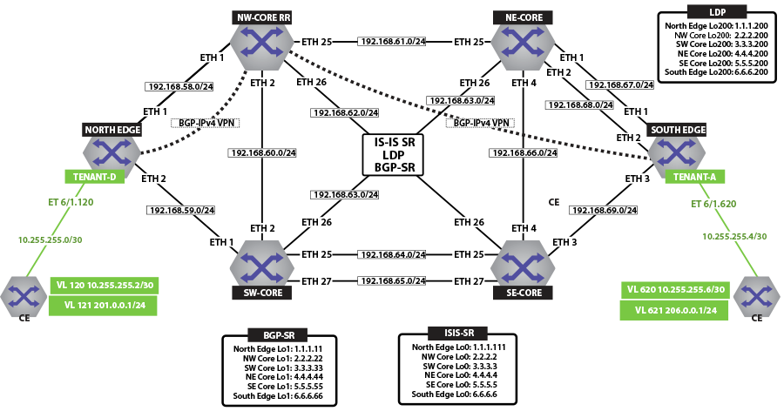Figure 15. IPv6 VPN Physical Topology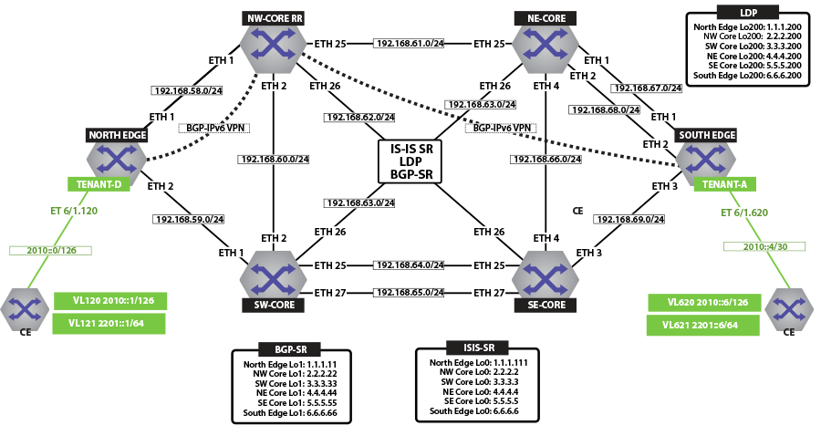

**IP VPN over ISIS-SR**

The following figure illustrates an overview of the combined control and data planes.

Figure 16. IPv4 VPN and IPv6 VPN Over ISIS-SR MPLS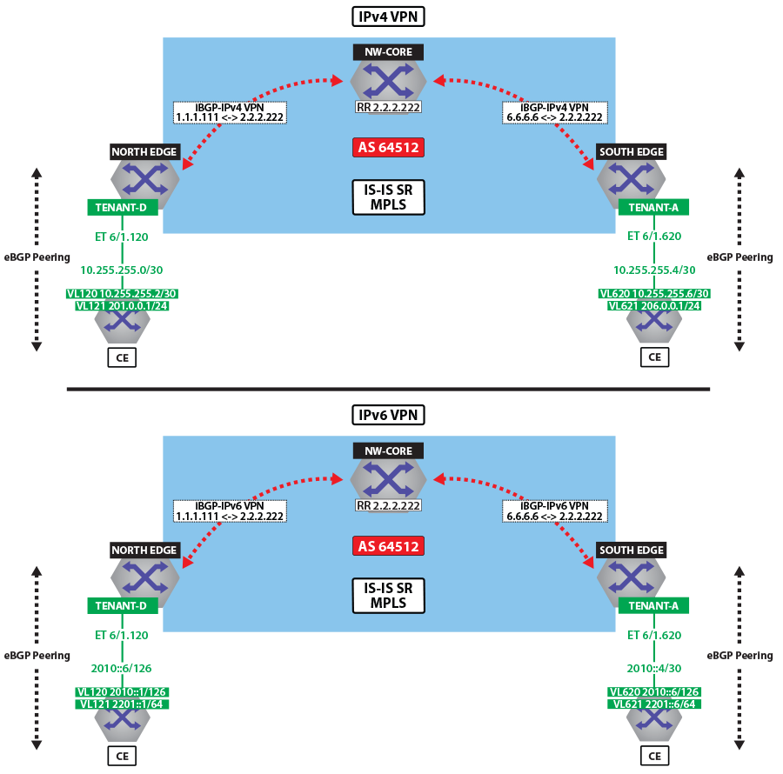

The next two figures illustrate the forwarding path and control plane for both IP traffic over ISIS MPLS segment routing.

Figure 17. IPv4 VPN Forwarding Over ISIS-SR MPLS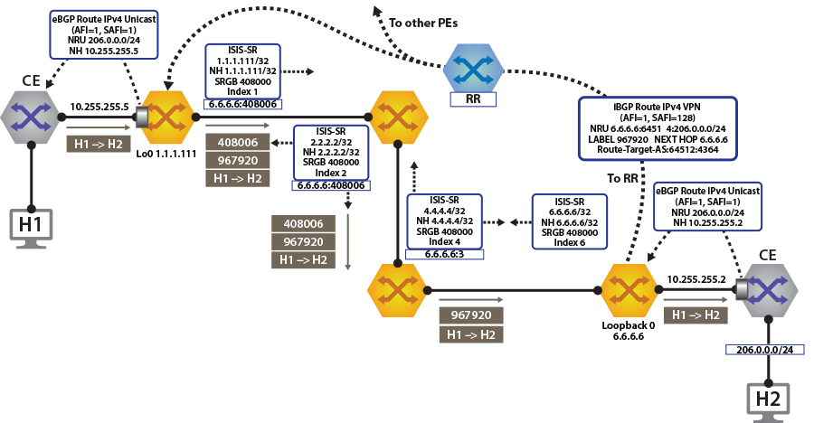Figure 18. IPv6 VPN Forwarding Over ISIS-SR MPLS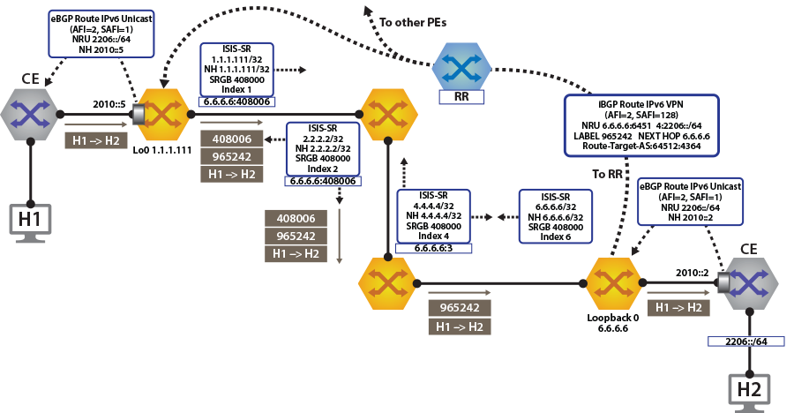

**View IPv4 and IPv6 Routes in the VRF**

North Edge and South Edge routers have an eBGP peering session out to the CE; and learning routes from CE and remote PE.

* The **show ip route vrf tenant-d** command displays IPv4 Routes in the VRF of North Edge.
* **north-edge# show ip route vrf tenant-d**
* **VRF: tenant-d**
* **Codes: C - connected, S - static, K - kernel,**
* **O - OSPF, IA - OSPF inter area, E1 - OSPF external type 1,**
* **E2 - OSPF external type 2, N1 - OSPF NSSA external type 1,**
* **N2 - OSPF NSSA external type2, B I - iBGP, B E - eBGP,**
* **R - RIP, I L1 - IS-IS level 1, I L2 - IS-IS level 2,**
* **O3 - OSPFv3, A B - BGP Aggregate, A O - OSPF Summary,**
* **NG - Nexthop Group Static Route, V - VXLAN Control Service,**
* **DH - DHCP client installed default route, M - Martian,**
* **DP - Dynamic Policy Route**
* **Gateway of last resort is not set**
* **B I 10.255.255.0/30 [200/0] via 6.6.6.6/32, IS-IS SR tunnel index 6, label 967920**
* **via 192.168.58.12, Ethernet1/1, label 408006**
* **C 10.255.255.4/30 is directly connected, Ethernet6/1.120**
* **B E 201.0.0.0/24 [200/0] via 10.255.255.6, Ethernet6/1.120**
* **B I 206.0.0.0/24 [200/0] via 6.6.6.6/32, IS-IS SR tunnel index 6, label 967920**

**via 192.168.58.12, Ethernet1/1, label 408006**

* The **show ip route vrf tenant-d** command displays IPv4 Routes in the VRF of South Edge.
* **south-edge# show ip route vrf tenant-d**
* **VRF: tenant-d**
* **Codes: C - connected, S - static, K - kernel,**
* **O - OSPF, IA - OSPF inter area, E1 - OSPF external type 1,**
* **E2 - OSPF external type 2, N1 - OSPF NSSA external type 1,**
* **N2 - OSPF NSSA external type2, B I - iBGP, B E - eBGP,**
* **R - RIP, I L1 - IS-IS level 1, I L2 - IS-IS level 2,**
* **O3 - OSPFv3, A B - BGP Aggregate, A O - OSPF Summary,**
* **NG - Nexthop Group Static Route, V - VXLAN Control Service,**
* **DH - DHCP client installed default route, M - Martian,**
* **DP - Dynamic Policy Route**
* **Gateway of last resort is not set**
* **C 10.255.255.0/30 is directly connected, Ethernet6/1.620**
* **B I 10.255.255.4/30 [200/0] via 1.1.1.111/32, IS-IS SR tunnel index 5, label 951536**
* **via 192.168.68.11, Ethernet2/1, label 408001**
* **B I 201.0.0.0/24 [200/0] via 1.1.1.111/32, IS-IS SR tunnel index 5, label 951536**
* **via 192.168.68.11, Ethernet2/1, label 408001**

**B E 206.0.0.0/24 [200/0] via 10.255.255.2, Ethernet6/1.620**

* The **show ipv6 route vrf tenant-d** command displays IPv6 Routes in the VRF of North Edge.
* **north-edge# show ipv6 route vrf tenant-d**
* **VRF: tenant-d**
* **Displaying 4 of 7 IPv6 routing table entries**
* **Codes: C - connected, S - static, K - kernel, O3 - OSPFv3, B - BGP, R - RIP, A B - BGP Aggregate, I L1 -**
* **IS-IS level 1, I L2 - IS-IS level 2, DH - DHCP, NG - Nexthop Group Static Route, M - Martian, DP - Dynamic**
* **Policy Route**
* **B 2010::/126 [200/0]**
* **via 6.6.6.6/32, IS-IS SR tunnel index 6, label 965242**
* **via 192.168.58.12, Ethernet1/1, label 408006**
* **C 2010::4/126 [0/0]**
* **via Ethernet6/1.120, directly connected**
* **B 2201::/64 [200/0]**
* **via 2010::6, Ethernet6/1.120**
* **B 2206::/64 [200/0]**
* **via 6.6.6.6/32, IS-IS SR tunnel index 6, label 965242**

**via 192.168.58.12, Ethernet1/1, label 408006**

* The **show ipv6 route vrf tenant-d** command displays IPv6 Routes in the VRF of South Edge.
* **south-edge# show ipv6 route vrf tenant-d**
* **VRF: tenant-d**
* **Displaying 4 of 7 IPv6 routing table entries**
* **Codes: C - connected, S - static, K - kernel, O3 - OSPFv3, B - BGP, R - RIP, A B - BGP Aggregate, I L1 -**
* **IS-IS level 1, I L2 - IS-IS level 2, DH - DHCP, NG - Nexthop Group Static Route, M - Martian, DP - Dynamic**
* **Policy Route**
* **C 2010::/126 [0/0]**
* **via Ethernet6/1.620, directly connected**
* **B 2010::4/126 [200/0]**
* **via 1.1.1.111/32, IS-IS SR tunnel index 5, label 948858**
* **via 192.168.68.11, Ethernet2/1, label 408001**
* **B 2201::/64 [200/0]**
* **via 1.1.1.111/32, IS-IS SR tunnel index 5, label 948858**
* **via 192.168.68.11, Ethernet2/1, label 408001**
* **B 2206::/64 [200/0]**

**via 2010::2, Ethernet6/1.620**

**Activating IP VPN**

In all scenarios, the IP VPN must be activated under BGP and neighbors configured to exchange the IP VPN NLRIs.The tenant’s VRF (tenant-d) is associated with a dynamically assigned label by BGP.

**North Edge**

**service routing protocols model multi-agent**

**router bgp 64512**

**router-id 1.1.1.111**

**maximum-paths 128 ecmp 128**

**neighbor 2.2.2.222 remote-as 64512**

**neighbor 2.2.2.222 update-source Loopback0**

**neighbor 2.2.2.222 bfd**

**neighbor 2.2.2.222 send-community extended**

**neighbor 2.2.2.222 maximum-routes 12000**

**!**

**address-family vpn-ipv4**

**neighbor 2.2.2.222 activate**

**neighbor default encapsulation mpls next-hop-self source-interface Loopback0**

**!**

**address-family vpn-ipv6**

**neighbor 2.2.2.222 activate**

**neighbor default encapsulation mpls next-hop-self source-interface Loopback0**

**!**

**South Edge**

**service routing protocols model multi-agent**

**router bgp 64512**

**router-id 6.6.6.6**

**maximum-paths 128 ecmp 128**

**neighbor 2.2.2.222 remote-as 64512**

**neighbor 2.2.2.222 update-source Loopback0**

**neighbor 2.2.2.222 bfd**

**neighbor 2.2.2.222 send-community extended**

**neighbor 2.2.2.222 maximum-routes 12000**

**!**

**address-family vpn-ipv4**

**neighbor 2.2.2.222 activate**

**neighbor default encapsulation mpls next-hop-self source-interface Loopback0**

**!**

**address-family vpn-ipv6**

**neighbor 2.2.2.222 activate**

**neighbor default encapsulation mpls next-hop-self source-interface Loopback0**

**!**

The configuration above provides the following:

* It enables the multi-agent routing protocol model, which is required for BGP VPN support.
* It sets the local autonomous system number to ***64512*** and configured the route-reflector for both IPv4 VPN and IPv6 VPN capabilities.
* It sets the IP VPN encapsulation type to MPLS (default).
* It specifies that ***Loopback0*** will be used as the next-hop for all advertised VPN routes. The underlay configuration must provide MPLS LSPs from remote PEs to this loopback interface address.

**Layer 3 Overlay Configuration**

Distribution of Layer 3 routes over BGP is enabled by configuring one or more IP VRFs under the router bgp configuration mode. Additionally, either IPv4 or IPv6 routing must be enabled in the VRF.

* Configure IP VRF in the North Edge router.
* **vrf instance tenant-d**
* **ip routing vrf tenant-d**
* **ipv6 unicast-routing vrf tenant-d**
* **!**
* **router bgp 64512**
* **vrf tenant-d**
* **rd 1.1.1.1:64514**
* **route-target import vpn-ipv4 64512:4364**
* **route-target import vpn-ipv6 64512:4364**
* **route-target export vpn-ipv4 64512:4364**
* **route-target export vpn-ipv6 64512:4364**
* **neighbor 10.255.255.6 remote-as 65011**
* **neighbor 10.255.255.6 maximum-routes 12000**
* **neighbor 2010::6 remote-as 65011**
* **neighbor 2010::6 maximum-routes 12000**
* **!**
* **address-family ipv6**
* **neighbor 2010::6 activate**
* **redistribute connected**

**!**

* Configure IP VRF in the South Edge router.
* **vrf instance tenant-d**
* **ip routing vrf tenant-d**
* **ipv6 unicast-routing vrf tenant-d**
* **!**
* **router bgp 64512**
* **vrf tenant-d**
* **rd 6.6.6.6:64514**
* **route-target import vpn-ipv4 64512:4364**
* **route-target import vpn-ipv6 64512:4364**
* **route-target export vpn-ipv4 64512:4364**
* **route-target export vpn-ipv6 64512:4364**
* **neighbor 10.255.255.2 remote-as 65010**
* **neighbor 10.255.255.2 maximum-routes 12000**
* **neighbor 2010::2 remote-as 65010**
* **neighbor 2010::2 maximum-routes 12000**
* **!**
* **address-family ipv6**
* **neighbor 2010::2 activate**
* **redistribute connected**

**!**

These IP VRF configurations provide the following functionalities:

* It defines overlay VRFs (tenant-d) on the PE and enables IP unicast routing.
* The VRF is assigned a unique Route-Distinguisher (RD). The RD allows the PE to advertise VPN routes for the same IP prefix that have been exported by different VRFs. The NLRI RouteKey of a route exported from the VRFs IPv4 table into VPN consists of both the RD and the original IP prefix.
* The Route-Target (RT) extended communities for the VRF. The RTs are associated with all routes exported from the VRF. Received VPN routes carrying at least one RT matching the VRFs configuration are imported into the VRF.

**Verifying IP VPNs over ISIS-SR**

* The **show bgp vpn-ipv4 summary** command displays the status of the VPN IP peers in the North Edge router with the BGP VPN enabled.
* **north-edge# show bgp vpn-ipv4 summary**
* **BGP summary information for VRF default**
* **Router identifier 1.1.1.111, local AS number 64512**
* **Neighbor Status Codes: m - Under maintenance**
* **Neighbor V AS MsgRcvd MsgSent InQ OutQ Up/Down State**
* **PfxRcd PfxAcc**
* **2.2.2.222 4 64512 172 45 0 0 00:17:16 Estab 2 2**
* **north-edge# show bgp vpn-ipv6 summary**
* **BGP summary information for VRF default**
* **Router identifier 1.1.1.111, local AS number 64512**
* **Neighbor Status Codes: m - Under maintenance**
* **Neighbor V AS MsgRcvd MsgSent InQ OutQ Up/Down State**
* **PfxRcd PfxAcc**

**2.2.2.222 4 64512 172 45 0 0 00:17:20 Estab 2 2**

* The **show bgp vpn-ipv4** command displays routes sent and received through IP VPN.
* **north-edge# show bgp vpn-ipv4**
* **BGP routing table information for VRF default**
* **Router identifier 1.1.1.111, local AS number 64512**
* **Route status codes: s - suppressed, * - valid, > - active, # - not installed, E - ECMP head, e - ECMP**
* **S - Stale, c - Contributing to ECMP, b - backup**
* **% - Pending BGP convergence**
* **Origin codes: i - IGP, e - EGP, ? - incomplete**
* **AS Path Attributes: Or-ID - Originator ID, C-LST - Cluster List, LL Nexthop - Link Local Nexthop**
* **Network Next Hop Metric LocPref Weight Path**
* **\* > RD: 6.6.6.6:64514 IPv4 prefix 10.255.255.0/30**
* **6.6.6.6 - 100 0 65010 i Or-ID: 6.6.6.6 C-LST: 2.2.2.222**
* **\* > RD: 1.1.1.1:64514 IPv4 prefix 10.255.255.4/30**
* **- - 100 0 65011 i**
* **\* > RD: 1.1.1.1:64514 IPv4 prefix 201.0.0.0/24**
* **- - 100 0 65011 i**
* **\* > RD: 6.6.6.6:64514 IPv4 prefix 206.0.0.0/24**
* **6.6.6.6 - 100 0 65010 i Or-ID: 6.6.6.6 C-LST: 2.2.2.222**
* **north-edge# show bgp vpn-ipv6**
* **BGP routing table information for VRF default**
* **Router identifier 1.1.1.111, local AS number 64512**
* **Route status codes: s - suppressed, * - valid, > - active, # - not installed, E - ECMP head, e - ECMP**
* **S - Stale, c - Contributing to ECMP, b - backup**
* **% - Pending BGP convergence**
* **Origin codes: i - IGP, e - EGP, ? - incomplete**
* **AS Path Attributes: Or-ID - Originator ID, C-LST - Cluster List, LL Nexthop - Link Local Nexthop**
* **Network Next Hop Metric LocPref Weight Path**
* **\* > RD: 6.6.6.6:64514 IPv6 prefix 2010::/126**
* **6.6.6.6 - 100 0 65010 i Or-ID: 6.6.6.6 C-LST: 2.2.2.222**
* **\* > RD: 1.1.1.1:64514 IPv6 prefix 2010::4/126**
* **- - 100 0 65011 i**
* **\* > RD: 1.1.1.1:64514 IPv6 prefix 2201::/64**
* **- - 100 0 65011 i**
* **\* > RD: 6.6.6.6:64514 IPv6 prefix 2206::/64**

**6.6.6.6 - 100 0 65010 i Or-ID: 6.6.6.6 C-LST: 2.2.2.222**

**Note:** Each entry in the table represents a BGP path. The path specific information includes the Route-Distinguisher and the IP prefix. Paths are either received from VPN peers or exported from local VRFs.

* The **show bgp vpn-ipv4 206.0.0.0/24 detail** and **show bgp vpn-ipv6 2206::/64 detail** commands display detailed view of the IP prefix route for ***206.0.0.0/24*** and ***2206.::/64*** of the North Edge router.
* **north-edge# show bgp vpn-ipv4 206.0.0.0/24 detail**
* **BGP routing table information for VRF default**
* **Router identifier 1.1.1.111, local AS number 64512**
* **BGP routing table entry for IPv4 prefix 206.0.0.0/24, Route Distinguisher: 6.6.6.6:64514**
* **Paths: 1 available**
* **65010**
* **6.6.6.6 from 2.2.2.222 (2.2.2.222)**
* **Origin IGP, metric -, localpref 100, weight 0, valid, internal, best**
* **Extended Community: Route-Target-AS:64512:4364**
* **MPLS label: 967920**
* **north-edge# show bgp vpn-ipv6 2206::/64 detail**
* **BGP routing table information for VRF default**
* **Router identifier 1.1.1.111, local AS number 64512**
* **BGP routing table entry for IPv6 prefix 2206::/64, Route Distinguisher: 6.6.6.6:64514**
* **Paths: 1 available**
* **65010**
* **6.6.6.6 from 2.2.2.222 (2.2.2.222)**
* **Origin IGP, metric -, localpref 100, weight 0, valid, internal, best**
* **Extended Community: Route-Target-AS:64512:4364**

**MPLS label: 965242**

**Note:** The output includes the RD and IP prefixes identifying the route. As seen in the output, the IPv4 VPN route is received from ***2.2.2.222*** because it is set-up to be a route-reflector, but the next hop is ***6.6.6.6***. Both are advertised with tenant VPN label ***967920*** and ***965242*** and an RT.

* The **show ip bgp vrf tenant-d** command displays the BGP table for the VRF containing the imported EVPN routes.
* **north-edge# show ip bgp vrf tenant-d**
* **BGP routing table information for VRF tenant-d**
* **Router identifier 1.1.1.1, local AS number 64512**
* **Route status codes: s - suppressed, * - valid, > - active, # - not installed, E - ECMP head, e - ECMP**
* **S - Stale, c - Contributing to ECMP, b - backup, L - labeled-unicast**
* **% - Pending BGP convergence**
* **Origin codes: i - IGP, e - EGP, ? - incomplete**
* **AS Path Attributes: Or-ID - Originator ID, C-LST - Cluster List, LL Nexthop - Link Local Nexthop**
* **Network Next Hop Metric LocPref Weight Path**
* **\* >Ec 10.255.255.0/30 6.6.6.6 - 100 0 65010 i Or-ID: 6.6.6.6 C-LST: 2.2.2.222**
* **\* ec 10.255.255.0/30 6.6.6.6 - 100 0 65010 i Or-ID: 6.6.6.6 C-LST: 2.2.2.222**
* **\* > 10.255.255.4/30 10.255.255.6 - 100 0 65011 i**
* **\* > 201.0.0.0/24 10.255.255.6 - 100 0 65011 i**
* **\* >Ec 206.0.0.0/24 6.6.6.6 - 100 0 65010 i Or-ID: 6.6.6.6 C-LST: 2.2.2.222**

**\* ec 206.0.0.0/24 6.6.6.6 - 100 0 65010 i Or-ID: 6.6.6.6 C-LST: 2.2.2.222**

**Note:** Each entry in the table represent a BGP path that is either locally redistributed and received into the VRF or imported from the IPv4 VPN table. VPN routes are received from router *2.2.2.222* C-List (cluster list - basically identifying this route as from a route-reflector) with originating router being *6.6.6.6*.

Finally, let us look at the routes in the VRF tenant-d.

**VRF: tenant-d**

**Codes: C - connected, S - static, K - kernel,**

**O - OSPF, IA - OSPF inter area, E1 - OSPF external type 1,**

**E2 - OSPF external type 2, N1 - OSPF NSSA external type 1,**

**N2 - OSPF NSSA external type2, B I - iBGP, B E - eBGP,**

**R - RIP, I L1 - IS-IS level 1, I L2 - IS-IS level 2,**

**O3 - OSPFv3, A B - BGP Aggregate, A O - OSPF Summary,**

**NG - Nexthop Group Static Route, V - VXLAN Control Service,**

**DH - DHCP client installed default route, M - Martian,**

**DP - Dynamic Policy Route**

**Gateway of last resort is not set**

**B I 10.255.255.0/30 [200/0] via 6.6.6.6/32, IS-IS SR tunnel index 6, label 967920**

**via 192.168.58.12, Ethernet1/1, label 408006**

**C 10.255.255.4/30 is directly connected, Ethernet6/1.120**

**B E 201.0.0.0/24 [200/0] via 10.255.255.6, Ethernet6/1.120**

**B I 206.0.0.0/24 [200/0] via 6.6.6.6/32, IS-IS SR tunnel index 6, label 967920**

**via 192.168.58.12, Ethernet1/1, label 408006**

**Note:** As displayed in the highlighted route above the label stack, the route is the transport label 408006 on top (this is the label to reach ***NH 6.6.6.6***), with the ***tenant-a*** VPN label ***967920*** next in the stack, identifying the route as belonging to ***tenant-d***.

A check of the Tunnel FIB confirms that ***408006*** is the ISIS-SR LSP.

**north-edge# show mpls tunnel fib**

**! 'show mpls tunnel fib' has been deprecated. Please use 'show tunnel fib [options]' moving forward.**

**Tunnel Type Index Endpoint Nexthop Interface Labels Forwarding**

**------------------- --------- ------------------ ------------------- ------------------ ----------------**

**IS-IS SR IPv4 9 2.2.2.22/32 192.168.58.12 Ethernet1/1 [ 3 ] None**

**LDP 4 2.2.2.200/32 192.168.58.12 Ethernet1/1 [ 3 ] None**

**IS-IS SR IPv4 2 2.2.2.222/32 192.168.58.12 Ethernet1/1 [ 3 ] None**

**IS-IS SR IPv4 4 3.3.3.3/32 192.168.58.12 Ethernet1/1 [ 408003 ] None**

**BGP LU 5 3.3.3.33/32 192.168.58.12 Ethernet1/1 [ 200033 ] None**

**LDP 5 3.3.3.200/32 192.168.58.12 Ethernet1/1 [ 904099 ] None**

**IS-IS SR IPv4 8 4.4.4.4/32 192.168.58.12 Ethernet1/1 [ 408004 ] None**

**IS-IS SR IPv4 5 4.4.4.44/32 192.168.58.12 Ethernet1/1 [ 408044 ] None**

**LDP 2 4.4.4.200/32 192.168.58.12 Ethernet1/1 [ 904098 ] None**

**IS-IS SR IPv4 3 5.5.5.5/32 192.168.58.12 Ethernet1/1 [ 408005 ] Primary**

**BGP LU 7 5.5.5.55/32 192.168.58.12 Ethernet1/1 [ 200055 ] None**

**LDP 3 5.5.5.200/32 192.168.58.12 Ethernet1/1 [ 904100 ] None**

**IS-IS SR IPv4 6 6.6.6.6/32 192.168.58.12 Ethernet1/1 [ 408006 ] Primary**

**BGP LU 8 6.6.6.66/32 192.168.58.12 Ethernet1/1 [ 200066 ] None**

**LDP 1 6.6.6.200/32 192.168.58.12 Ethernet1/1 [ 904097 ] None**

**IS-IS SR IPv4 1 23.1.1.11/32 192.168.1.154 Ethernet36/1 [ 3 ] Primary**

**IS-IS SR IPv4 7 23.1.1.33/32 192.168.1.174 Ethernet23/1 [ 3 ] Primary**

**IP VPNs Over LDP**

The following figures illustrate an overview of the combined control and data planes.

Figure 19. IPv4 VPN and IPv6 VPN Over LDP MPLS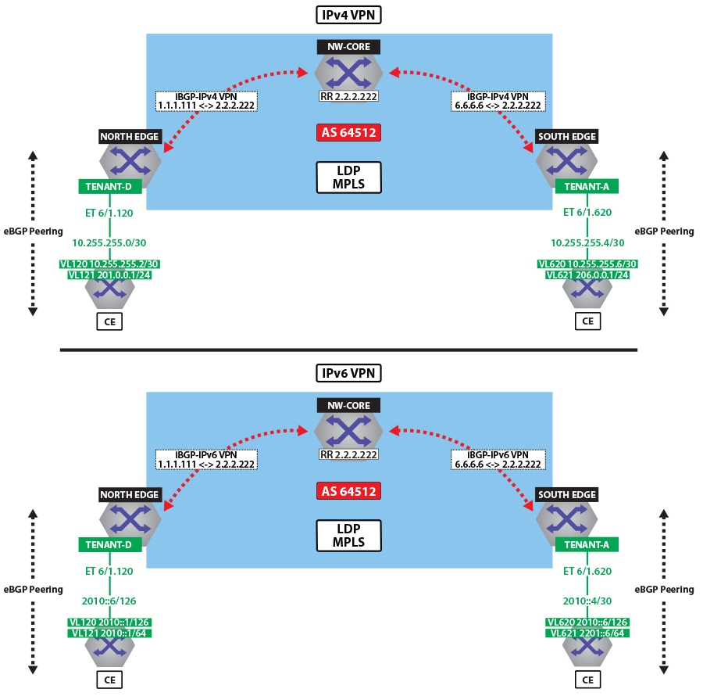Figure 20. IPv4 VPN Forwarding Over LDP MPLS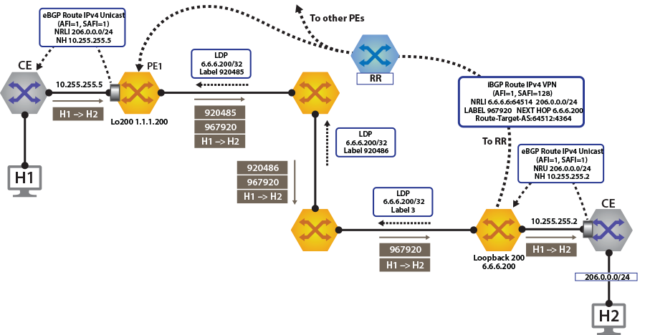Figure 21. IPv6 VPN Forwarding Over LDP MPLS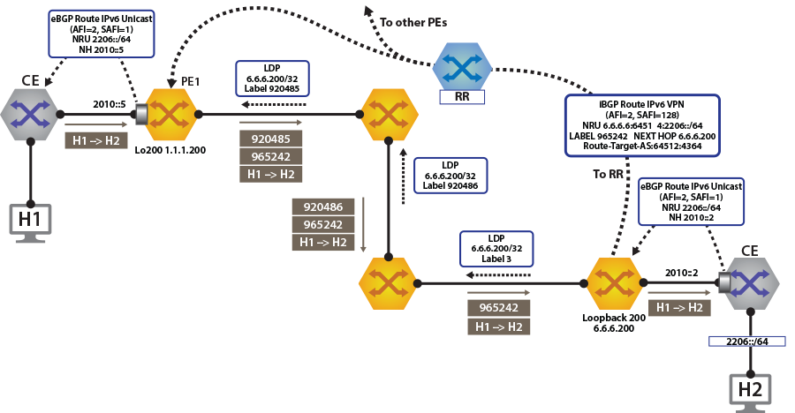

To switch to using the MPLS LDP transport, we just need to change the next-hop we advertised for the VPN routes. As shown, the next hop needs to be set to ***loopback 200*** for using the LDP LSP.

This is achieved by configuring the next-hop for the EVPN routes on both north and south edge routers.

**router bgp 64512**

**!**

**address-family evpn**

**neighbor default encapsulation mpls next-hop-self source-interface Loopback200**

After this is configured, check the BGP updates and the routes in the VRF. The output again includes the RD and IP prefix identifying the route. Now the NH is set to ***6.6.6.200*** for ***tenant-d***.

**north-edge# show bgp vpn-ipv4 206.0.0.0/24 detail**

**BGP routing table information for VRF default**

**Router identifier 1.1.1.111, local AS number 64512**

**BGP routing table entry for IPv4 prefix 206.0.0.0/24, Route Distinguisher: 6.6.6.6:64514**

**Paths: 1 available**

**65010**

**6.6.6.200 from 2.2.2.222 (2.2.2.222)**

**Origin IGP, metric -, localpref 100, weight 0, valid, internal, best**

**Extended Community: Route-Target-AS:64512:4364**

**MPLS label: 967920**

**north-edge#**

**north-edge# show bgp vpn-ipv6 2206::/64 detail**

**BGP routing table information for VRF default**

**Router identifier 1.1.1.111, local AS number 64512**

**BGP routing table entry for IPv6 prefix 2206::/64, Route Distinguisher: 6.6.6.6:64514**

**Paths: 1 available**

**65010**

**6.6.6.200 from 2.2.2.222 (2.2.2.222)**

**Origin IGP, metric -, localpref 100, weight 0, valid, internal, best**

**Extended Community: Route-Target-AS:64512:4364**

**MPLS label: 965242**

**north-edge#**

**Note:** The VPN label has not changed from the ISIS-SR case above (***967920*** and ***965242***), reinforcing the fact that the BGP VPN label is orthogonal to the transport label.

**north-edge# show ip route vrf tenant-d**

**VRF: tenant-d**

**Codes: C - connected, S - static, K - kernel,**

**O - OSPF, IA - OSPF inter area, E1 - OSPF external type 1,**

**E2 - OSPF external type 2, N1 - OSPF NSSA external type 1,**

**N2 - OSPF NSSA external type2, B I - iBGP, B E - eBGP,**

**R - RIP, I L1 - IS-IS level 1, I L2 - IS-IS level 2,**

**O3 - OSPFv3, A B - BGP Aggregate, A O - OSPF Summary,**

**NG - Nexthop Group Static Route, V - VXLAN Control Service,**

**DH - DHCP client installed default route, M - Martian,**

**DP - Dynamic Policy Route**

**Gateway of last resort is not set**

**B I 10.255.255.0/30 [200/0] via 6.6.6.200/32, LDP tunnel index 1, label 967920**

**via 192.168.58.12, Ethernet1/1, label 904097**

**C 10.255.255.4/30 is directly connected, Ethernet6/1.120**

**B E 201.0.0.0/24 [200/0] via 10.255.255.6, Ethernet6/1.120**

**B I 206.0.0.0/24 [200/0] via 6.6.6.200/32, LDP tunnel index 1, label 967920**

**via 192.168.58.12, Ethernet1/1, label 904097**

**north-edge(config-router-bgp)# show ipv6 route vrf tenant-d**

**VRF: tenant-d**

**Displaying 4 of 7 IPv6 routing table entries**

**Codes: C - connected, S - static, K - kernel, O3 - OSPFv3, B - BGP, R - RIP, A B - BGP Aggregate,**

**I L1 - IS-IS level 1, I L2 - IS-IS level 2, DH - DHCP, NG - Nexthop Group Static Route,**

**M - Martian, DP - Dynamic Policy Route**

**B 2010::/126 [200/0]**

**via 6.6.6.6/32, IS-IS SR tunnel index 6, label 965242**

**via 192.168.58.12, Ethernet1/1, label 408006**

**C 2010::4/126 [0/0]**

**via Ethernet6/1.120, directly connected**

**B 2201::/64 [200/0]**

**via 2010::6, Ethernet6/1.120**

**B 2206::/64 [200/0]**

**via 6.6.6.6/32, IS-IS SR tunnel index 6, label 965242**

**via 192.168.58.12, Ethernet1/1, label 408006**

**Note:** As seen from the highlighted route above the label stack, the route are the transport label ***904097*** on top (this is the label path to reach ***NH 6.6.6.200***), with the ***tenant-d*** VPN label ***967920*** next in the stack, and identifying the route as belonging to ***tenant-a***.

A capture of the dataplane on North-Edge matching on the LDP transport label confirms the encapsulated traffic on the wire. ***904097:976920:[Source IP Address][Destination IP Address]***.

**IP VPNs Over BGP-SR**

The following figures illustrate an overview of the combined control and data planes.

Figure 22. IPv4 VPN and IPv6 VPN Over BGP-SR MPLS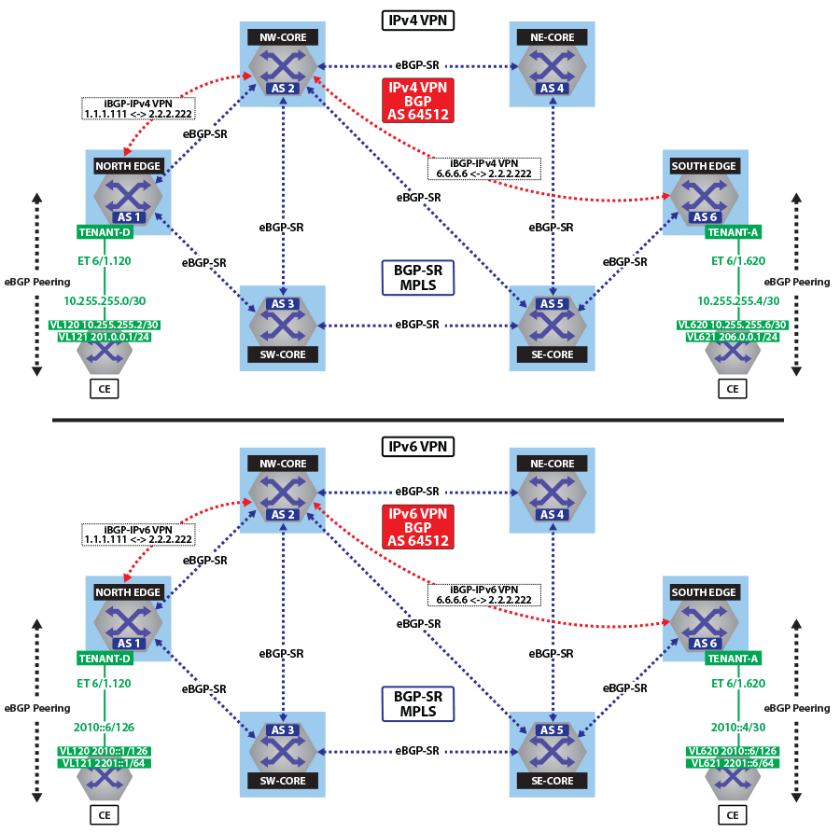Figure 23. IPv4 VPN Forwarding Over BGP-SR MPLS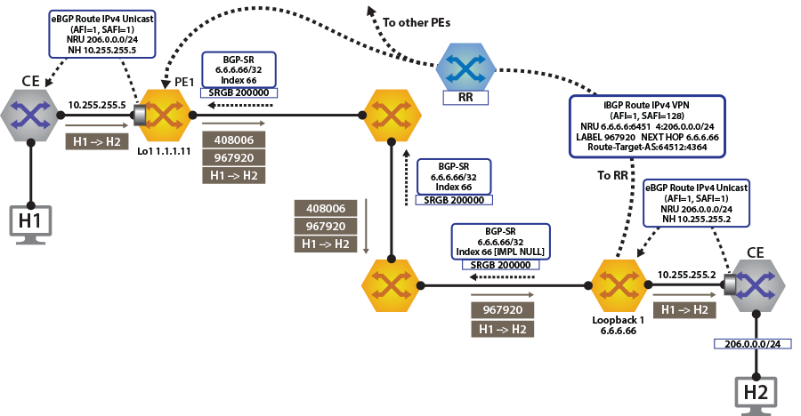Figure 24. IPv6 VPN Forwarding Over BGP-SR MPLS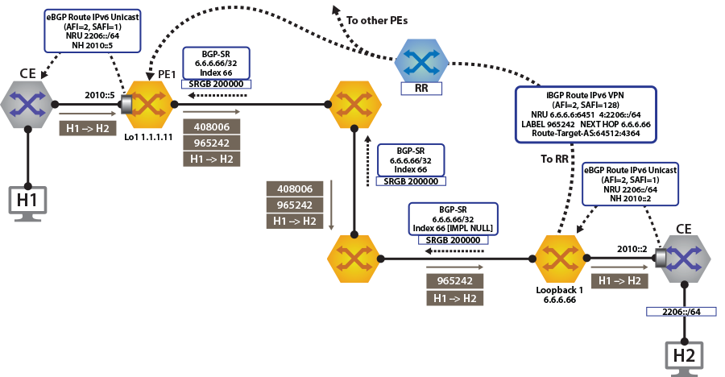

To switch to using the MPLS BGP-SR transport, we just need to change the next-hop we advertised for the VPN routes. As shown, the next hop needs to be set to ***loopback 1*** for using the BGP-SR LSP.

This is achieved by configuring the next-hop for EVPN routes.

**router bgp 64512**

**!**

**address-family evpn**

**neighbor default encapsulation mpls next-hop-self source-interface Loopback1**

Once this is configured, we can check the BGP updates and the routes in the VRF. The output again includes the RD and IP prefix identifying the route. As seen in the output, we now have the NH set to ***6.6.6.66*** for***tenant-d***.

**north-edge# show bgp vpn-ipv4 206.0.0.0/24 detail**

**BGP routing table information for VRF default**

**Router identifier 1.1.1.111, local AS number 64512**

**BGP routing table entry for IPv4 prefix 206.0.0.0/24, Route Distinguisher: 6.6.6.6:64514**

**Paths: 1 available**

**65010**

**6.6.6.66 from 2.2.2.222 (2.2.2.222)**

**Origin IGP, metric -, localpref 100, weight 0, valid, internal, best**

**Extended Community: Route-Target-AS:64512:4364**

**MPLS label: 967920**

**north-edge#**

**north-edge#show bgp vpn-ipv6 2206::/64 detail**

**BGP routing table information for VRF default**

**Router identifier 1.1.1.111, local AS number 64512**

**BGP routing table entry for IPv6 prefix 2206::/64, Route Distinguisher: 6.6.6.6:64514**

**Paths: 1 available**

**65010**

**6.6.6.66 from 2.2.2.222 (2.2.2.222)**

**Origin IGP, metric -, localpref 100, weight 0, valid, internal, best**

**Extended Community: Route-Target-AS:64512:4364**

**MPLS label: 965242**

**north-edge#**

**Note:** The VPN label has not changed from the ISIS-SR case above (***967920*** and ***965242***), reinforcing the fact that the BGP VPN label is orthogonal to the transport label.

The output again includes the RD and IP prefix identifying the route. As seen in the output, we now have the NH set to ***6.6.6.66*** for ***tenant-d***.

**north-edge# show bgp vpn-ipv4 206.0.0.0/24 detail**

**BGP routing table information for VRF default**

**Router identifier 1.1.1.111, local AS number 64512**

**BGP routing table entry for IPv4 prefix 206.0.0.0/24, Route Distinguisher: 6.6.6.6:64514**

**Paths: 1 available**

**65010**

**6.6.6.66 from 2.2.2.222 (2.2.2.222)**

**Origin IGP, metric -, localpref 100, weight 0, valid, internal, best**

**Extended Community: Route-Target-AS:64512:4364**

**MPLS label: 967920**

**north-edge#**

**north-edge# show bgp vpn-ipv6 2206::/64 detail**

**BGP routing table information for VRF default**

**Router identifier 1.1.1.111, local AS number 64512**

**BGP routing table entry for IPv6 prefix 2206::/64, Route Distinguisher: 6.6.6.6:64514**

**Paths: 1 available**

**65010**

**6.6.6.66 from 2.2.2.222 (2.2.2.222)**

**Origin IGP, metric -, localpref 100, weight 0, valid, internal, best**

**Extended Community: Route-Target-AS:64512:4364**

**MPLS label: 965242**

**north-edge#**

**Note:** The VPN label has not changed from the ISIS-SR case above (***967920*** and ***965242***), reinforcing that the BGP VPN label is orthogonal to the transport label.

As displayed in the highlighted route above the label stack, the route are the transport label ***200066*** on top (this is the label path to reach ***NH 6.6.6.66***), with the ***tenant-d*** VPN label ***967920*** next in the stack, and identifying the route as belonging to ***tenant-a***.

**north-edge# show ip route vrf tenant-d**

**VRF: tenant-d**

**Codes: C - connected, S - static, K - kernel,**

**O - OSPF, IA - OSPF inter area, E1 - OSPF external type 1,**

**E2 - OSPF external type 2, N1 - OSPF NSSA external type 1,**

**N2 - OSPF NSSA external type2, B I - iBGP, B E - eBGP,**

**R - RIP, I L1 - IS-IS level 1, I L2 - IS-IS level 2,**

**O3 - OSPFv3, A B - BGP Aggregate, A O - OSPF Summary,**

**NG - Nexthop Group Static Route, V - VXLAN Control Service,**

**DH - DHCP client installed default route, M - Martian,**

**DP - Dynamic Policy Route**

**Gateway of last resort is not set**

**B I 10.255.255.0/30 [200/0] via 6.6.6.66/32, BGP LU tunnel index 8, label 967920**

**via 192.168.58.12, Ethernet1/1, label 200066**

**via 192.168.59.12, Ethernet2/1, label 200066**

**C 10.255.255.4/30 is directly connected, Ethernet6/1.120**

**B E 201.0.0.0/24 [200/0] via 10.255.255.6, Ethernet6/1.120**

**B I 206.0.0.0/24 [200/0] via 6.6.6.66/32, BGP LU tunnel index 8, label 967920**

**via 192.168.58.12, Ethernet1/1, label 200066**

**via 192.168.59.12, Ethernet2/1, label 200066**

**north-edge(config-router-bgp)# show ipv6 route vrf tenant-d**

**VRF: tenant-d**

**Displaying 4 of 7 IPv6 routing table entries**

**Codes: C - connected, S - static, K - kernel, O3 - OSPFv3, B - BGP, R - RIP, A B - BGP Aggregate, I L1 -**

**IS-IS level 1, I L2 - IS-IS level 2, DH - DHCP, NG - Nexthop Group Static Route, M - Martian, DP - Dynamic**

**Policy Route**

**B 2010::/126 [200/0]**

**via 6.6.6.66/32, BGP LU tunnel index 8, label 965242**

**via 192.168.58.12, Ethernet1/1, label 200066**

**via 192.168.59.12, Ethernet2/1, label 200066**

**C 2010::4/126 [0/0]**

**via Ethernet6/1.120, directly connected**

**B 2201::/64 [200/0]**

**via 2010::6, Ethernet6/1.120**

**B 2206::/64 [200/0]**

**via 6.6.6.66/32, BGP LU tunnel index 8, label 965242**

**via 192.168.58.12, Ethernet1/1, label 200066**

**via 192.168.59.12, Ethernet2/1, label 200066**

A capture of the data-plane on North-Edge matching on the BGP-SR transport label confirms the encapsulated traffic on the wire. ***200066:976920:[Source IP Address][Destination IP Address]***.

**monitor session 1 source Ethernet1/1 tx**

**monitor session 1 destination Cpu**

**north-edge(config-router-bgp)# bash tcpdump -nei mirror0 -q -c 10 mpls 200066**

**tcpdump: verbose output suppressed, use -v or -vv for full protocol decode**

**listening on mirror0, link-type EN10MB (Ethernet), capture size 262144 bytes**

**16:37:15.074916 28:99:3a:4d:3e:f1 > 28:99:3a:4d:3a:f3, MPLS unicast, length 122: MPLS (label 200066, exp 0,**

**ttl 63) (label 967920, exp 0, [S], ttl 63) 10.255.255.6 > 206.0.0.1: ICMP echo request, id 22573, seq 1,**

**length 80**

**16:37:15.075088 28:99:3a:4d:3e:f1 > 28:99:3a:4d:3a:f3, MPLS unicast, length 122: MPLS (label 200066, exp 0,**

**ttl 63) (label 967920, exp 0, [S], ttl 63) 10.255.255.6 > 206.0.0.1: ICMP echo request, id 22573, seq 2, length 80**